**Name: Manas Rustagi**

**Python Assignment 1 TechShop**

**Customer Class :**

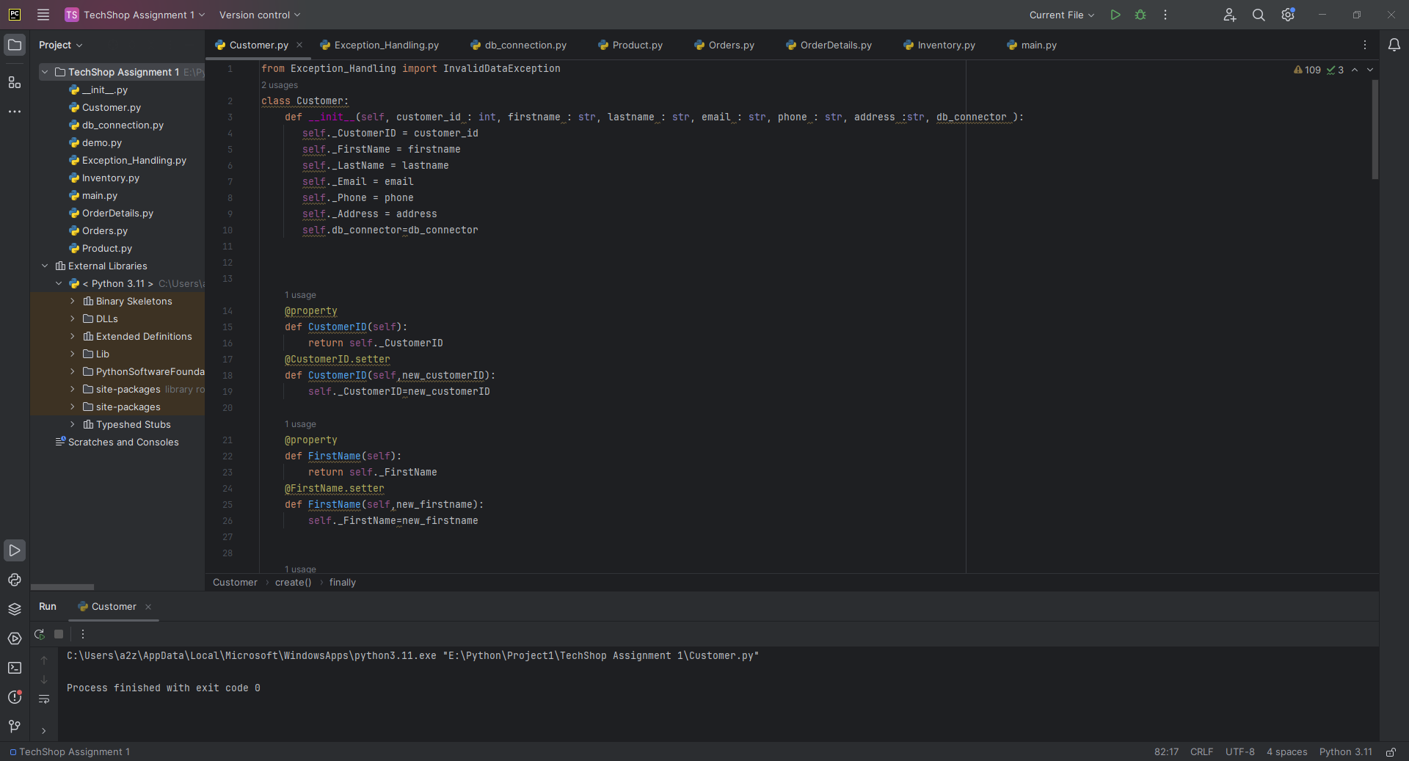

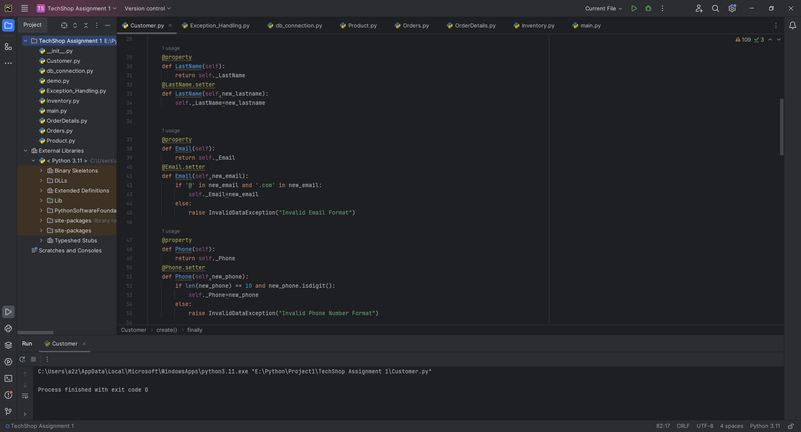

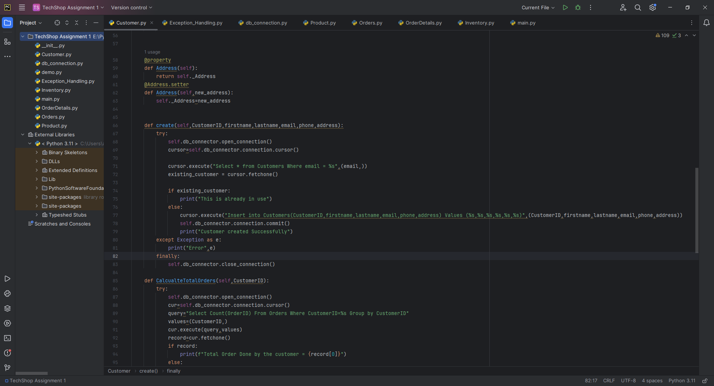

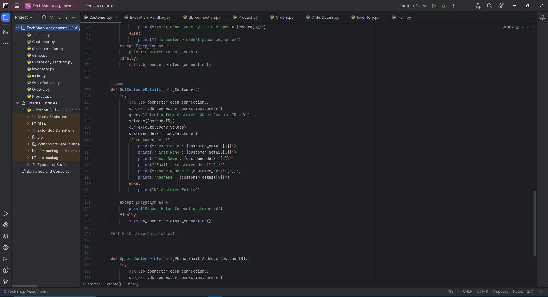

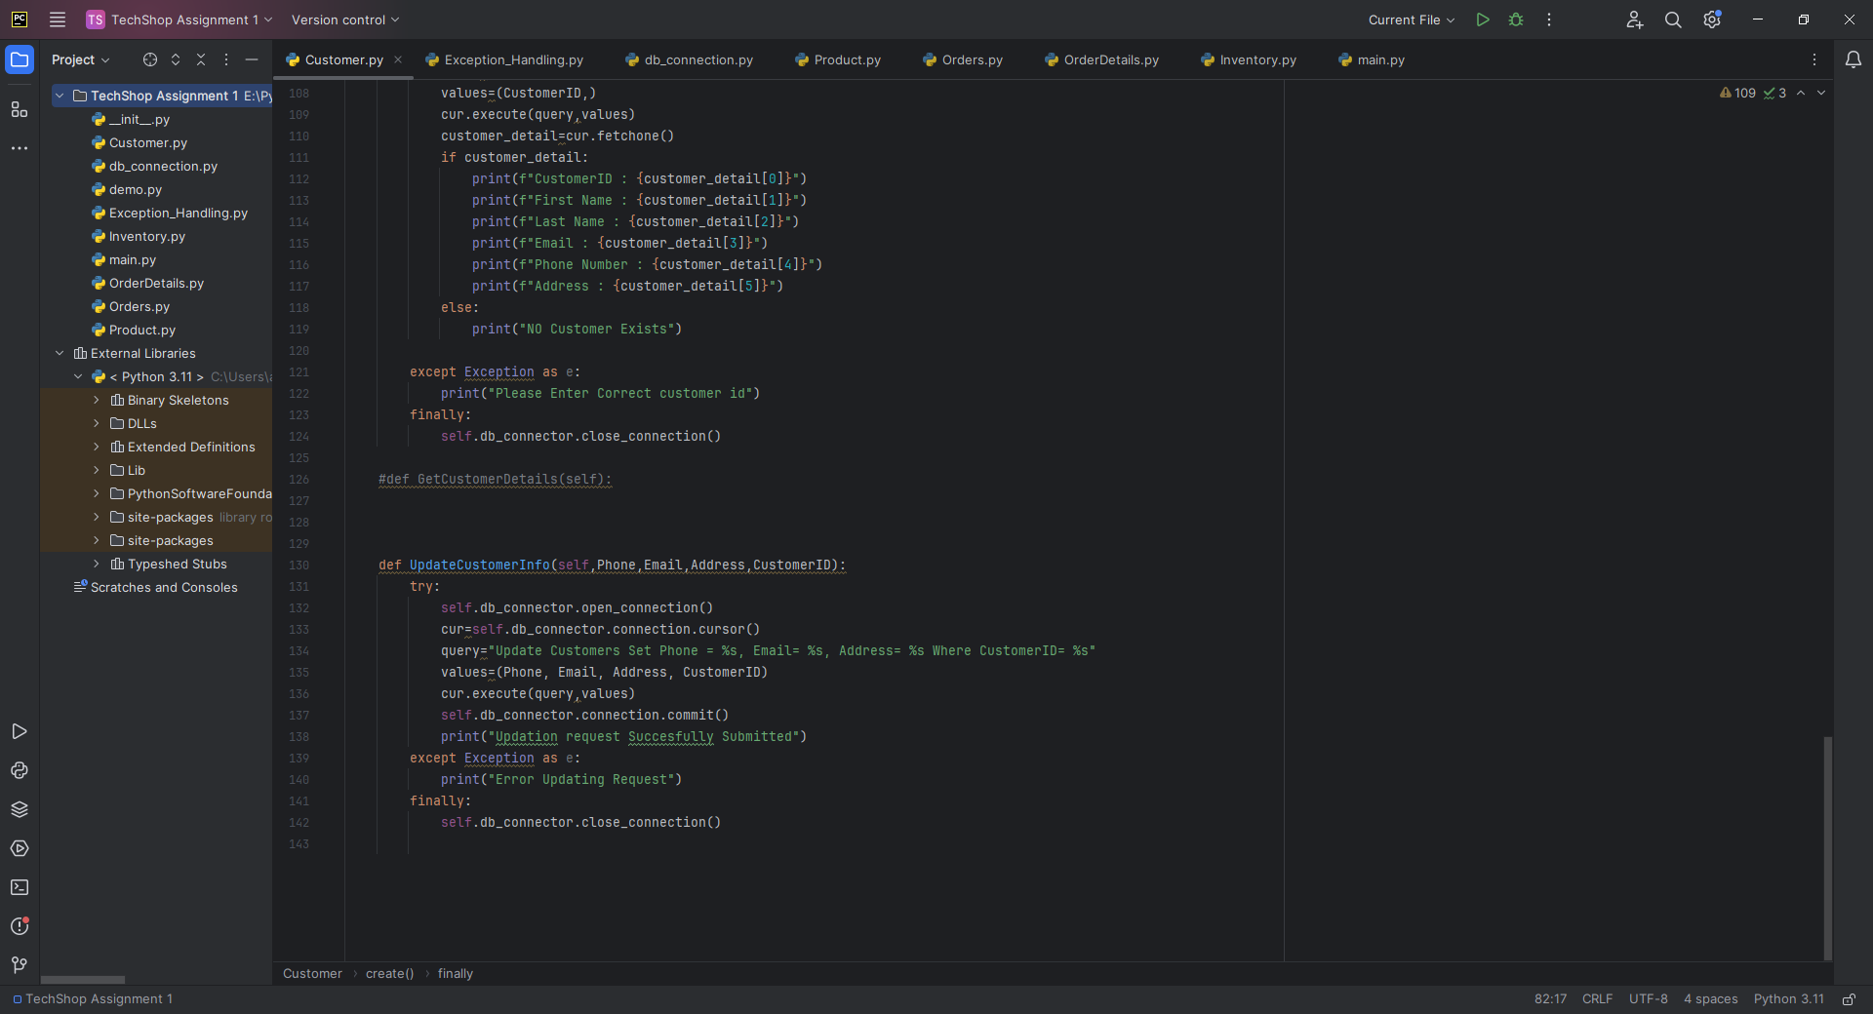

Customer created Successfully(CustomerID=12)

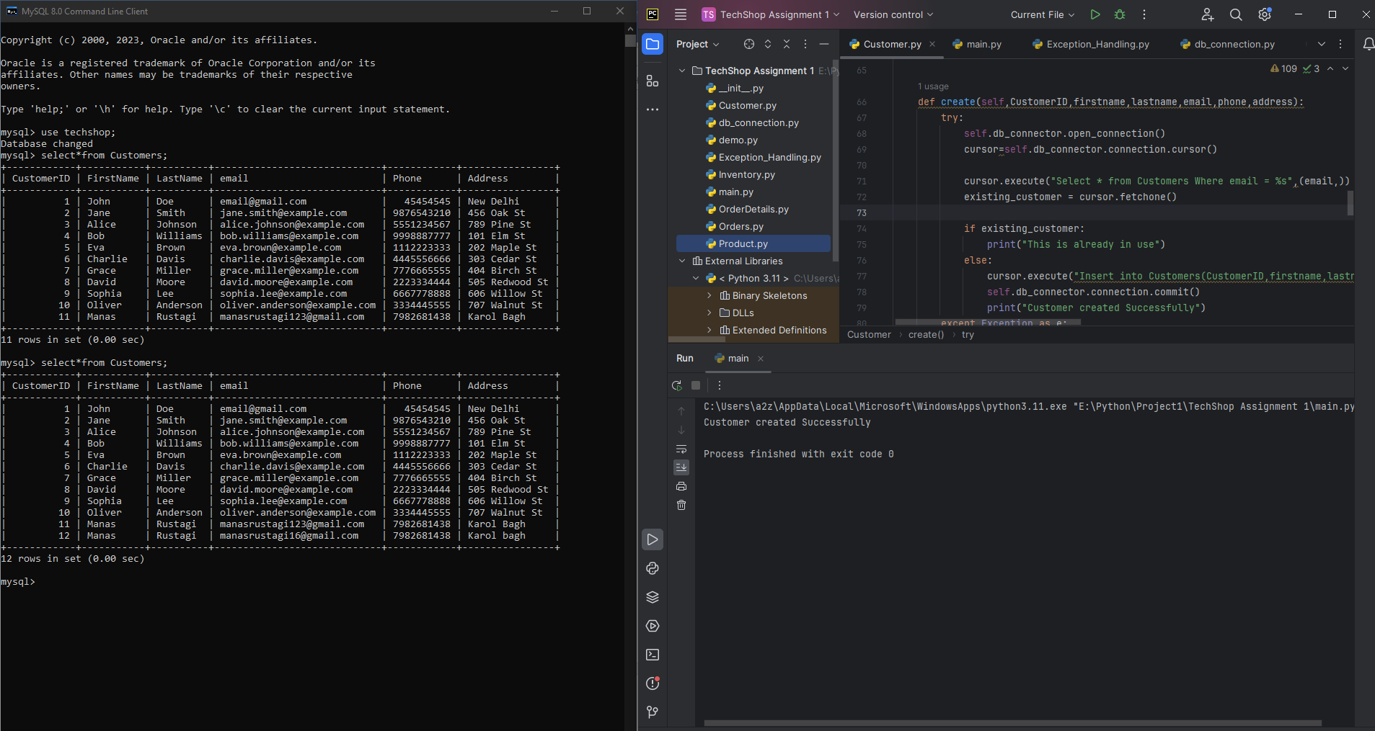

Email Id already exists (Cannot create New user)

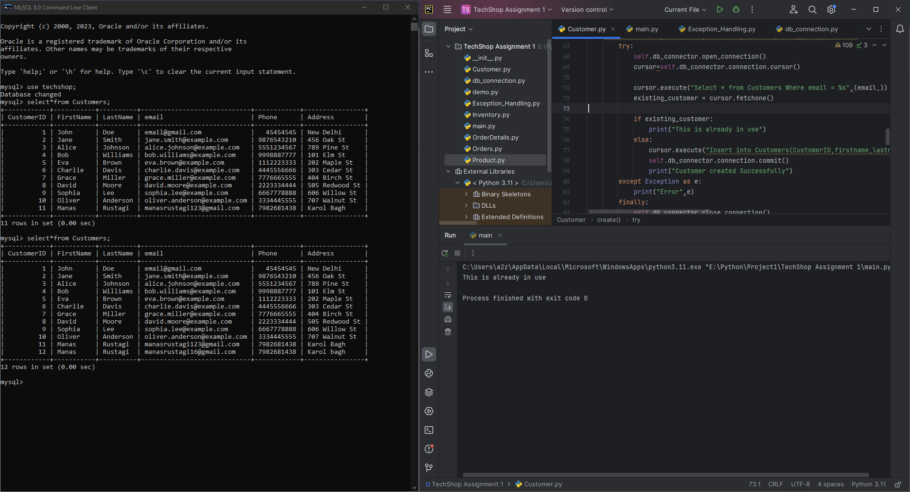

Total Orders Done by a Customer(CustomerID=1)

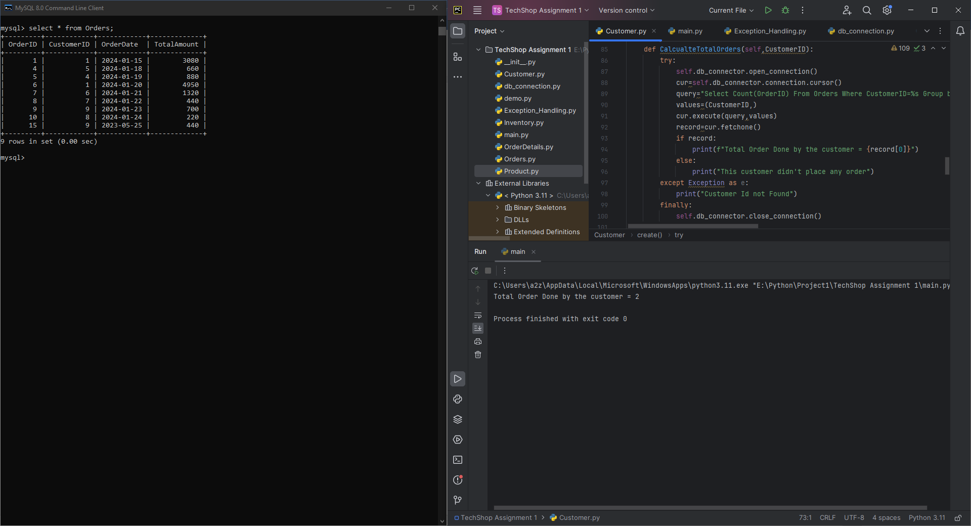

Getting Info about a Customer(CustomerID=2)

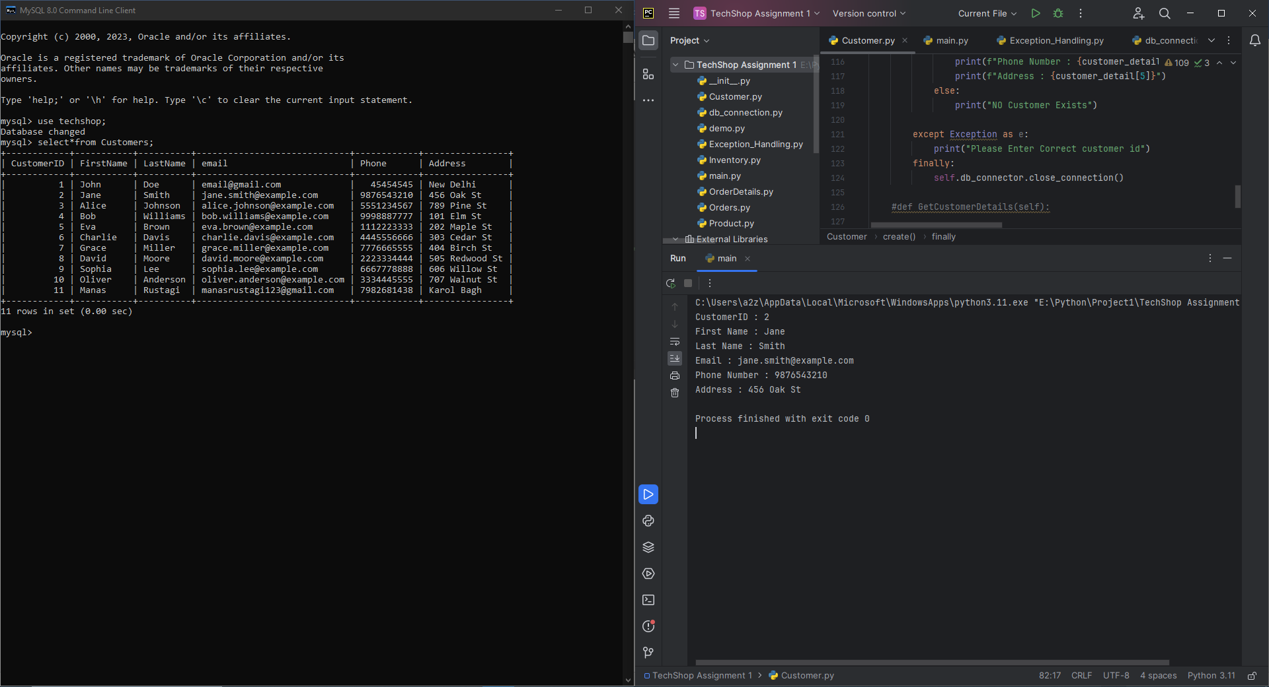

Updating Customer Info(CustomerId=2)

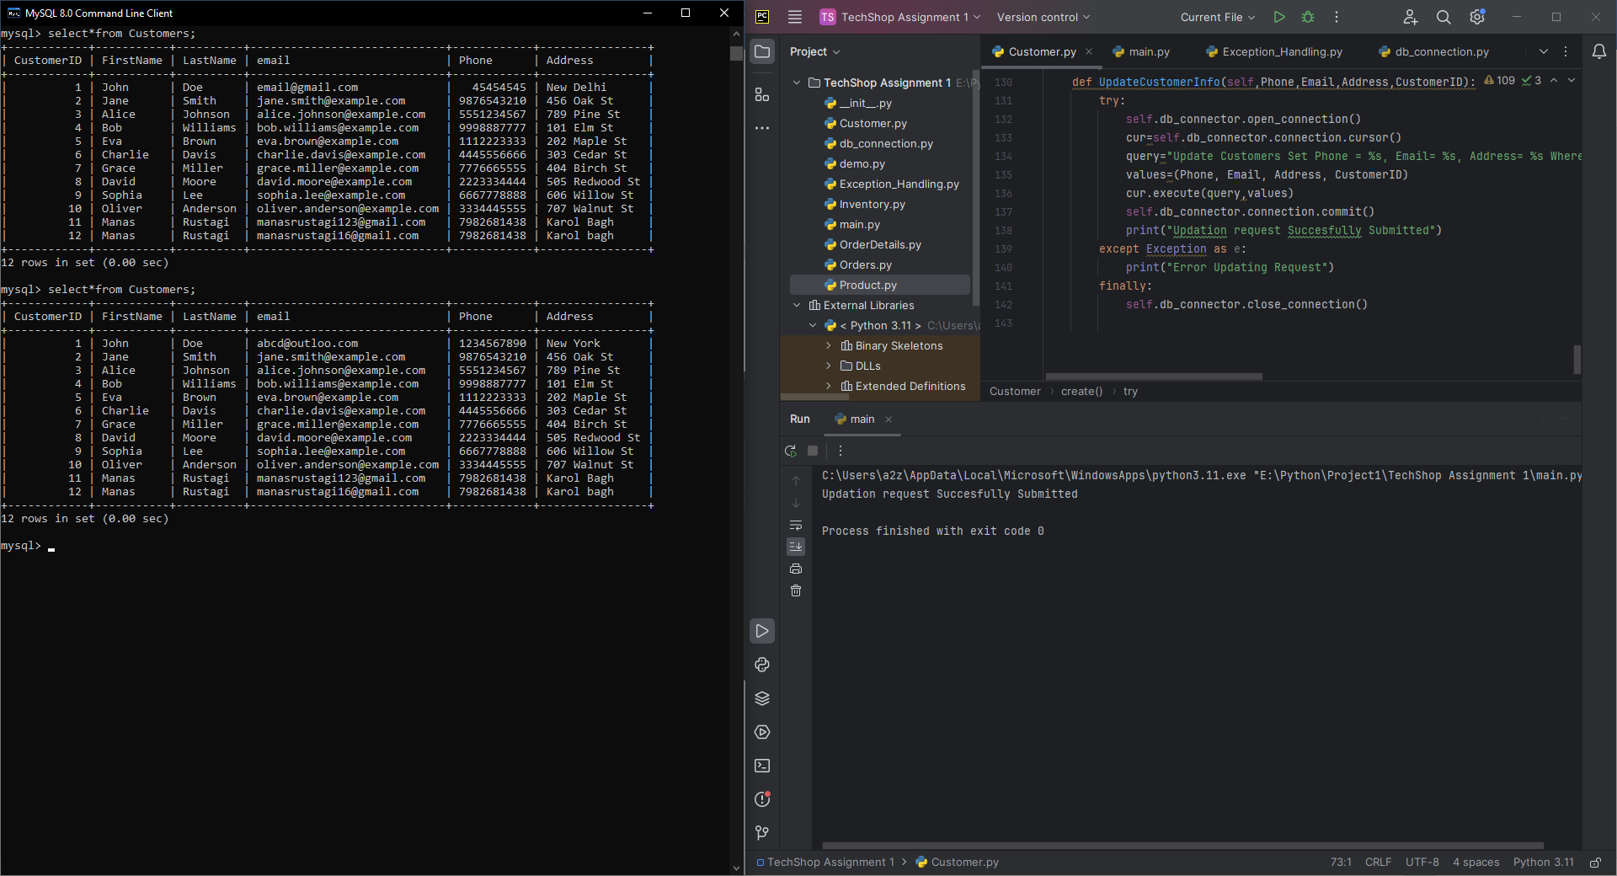

Products Class:

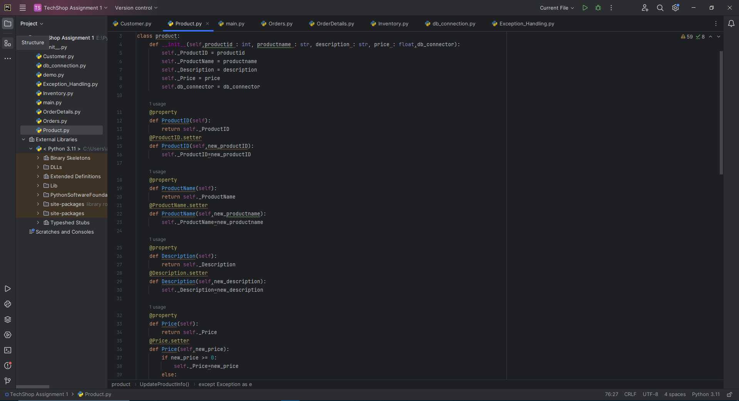

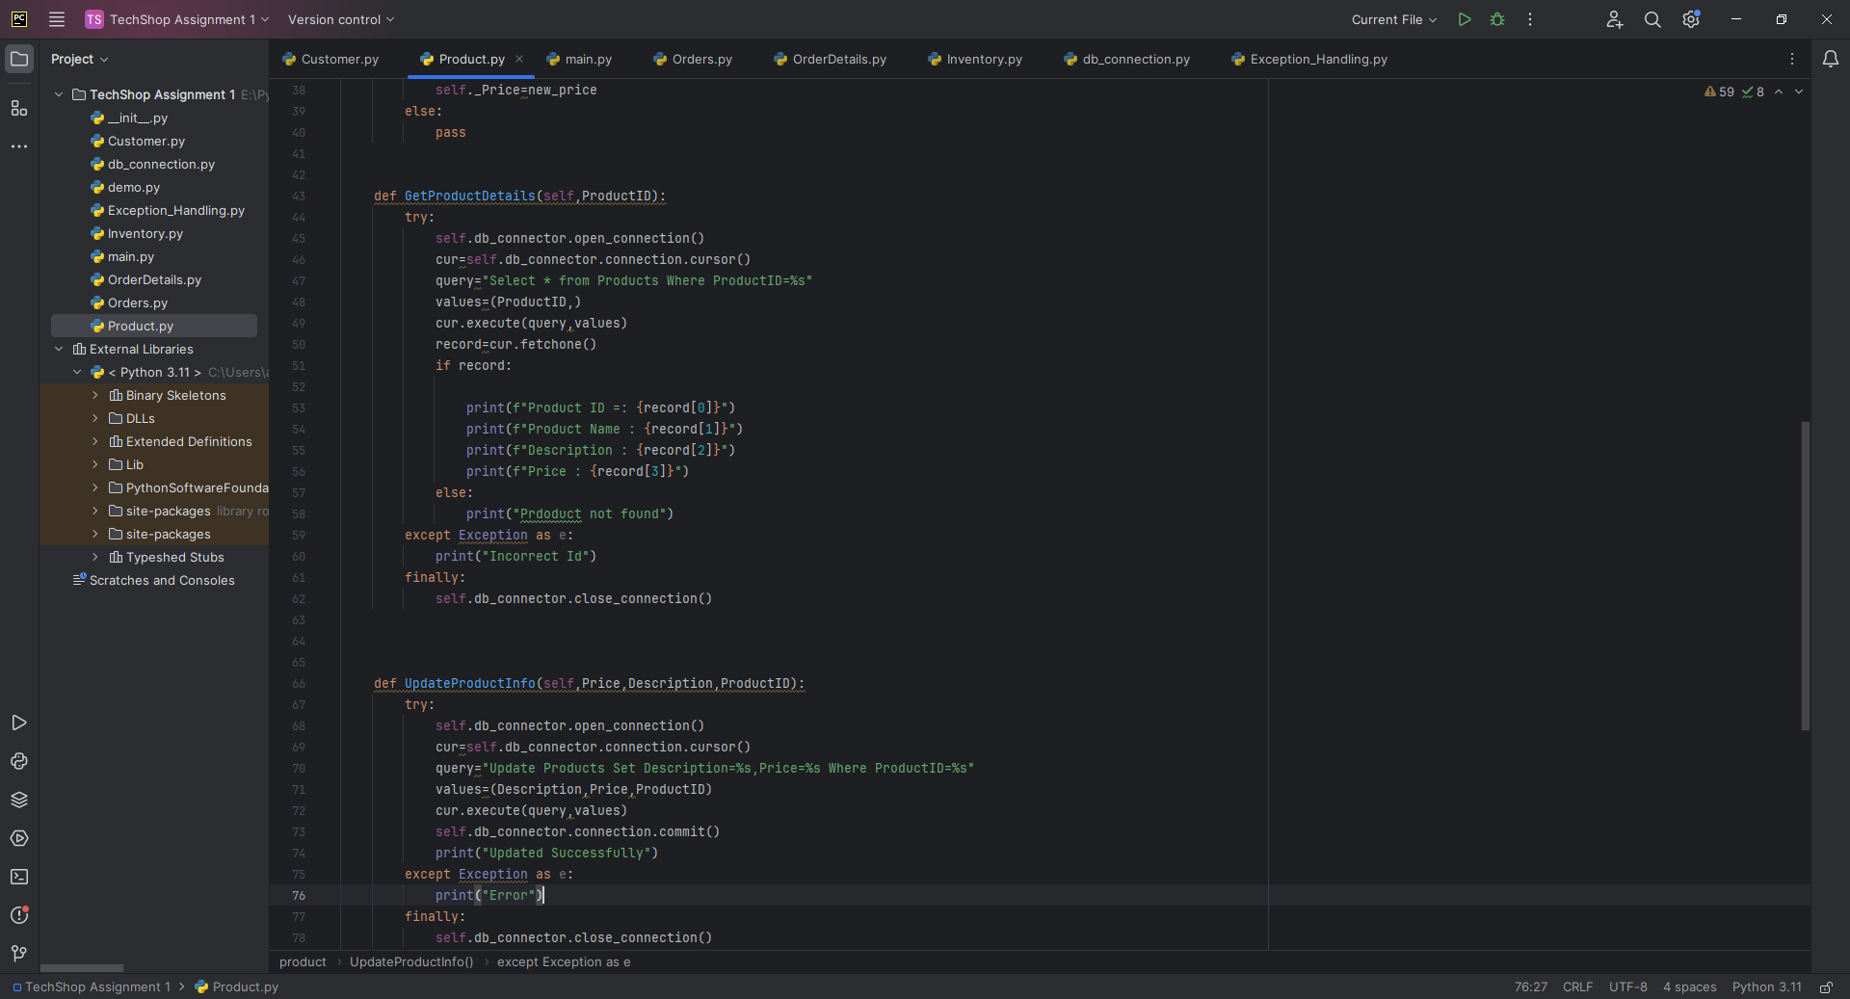

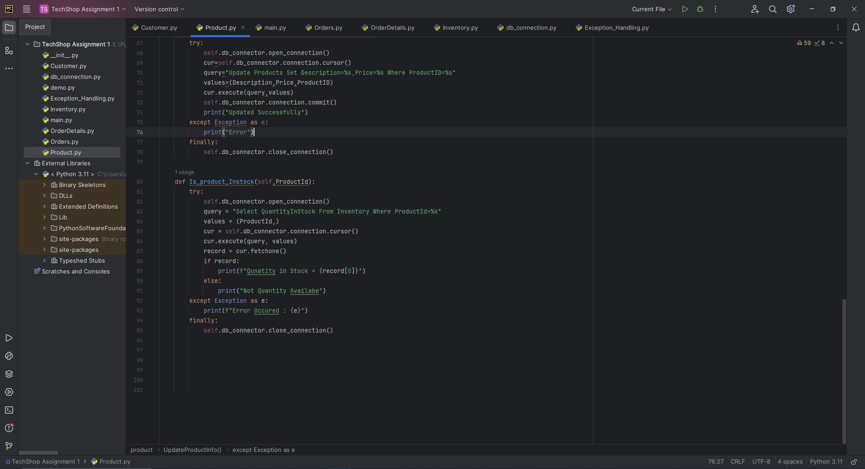

Getting Product Info(ProductID=5)

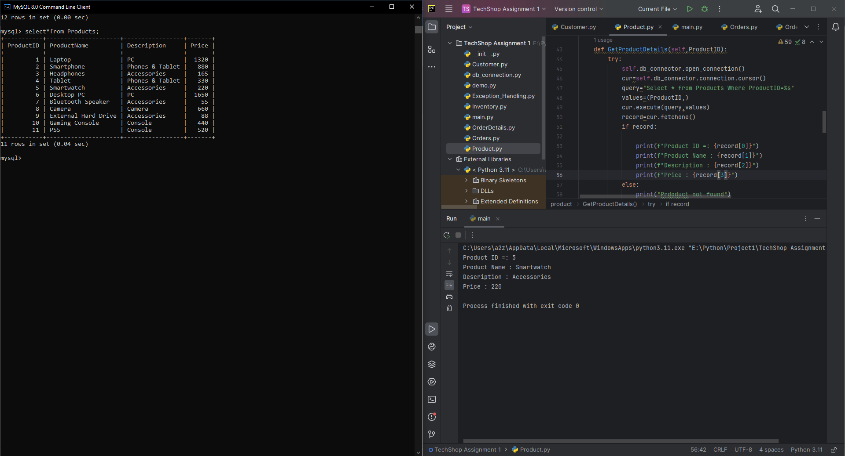

Updating Product Info(ProductId=2)

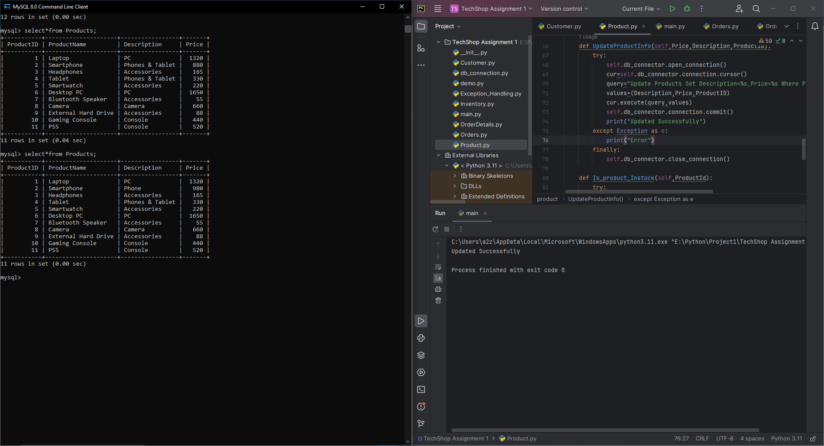

Checking if Product is available or not in the Inventory(Product=5)

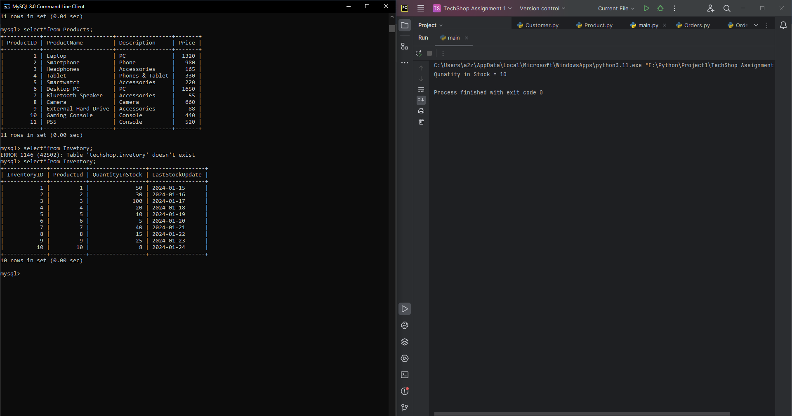

Order Class:

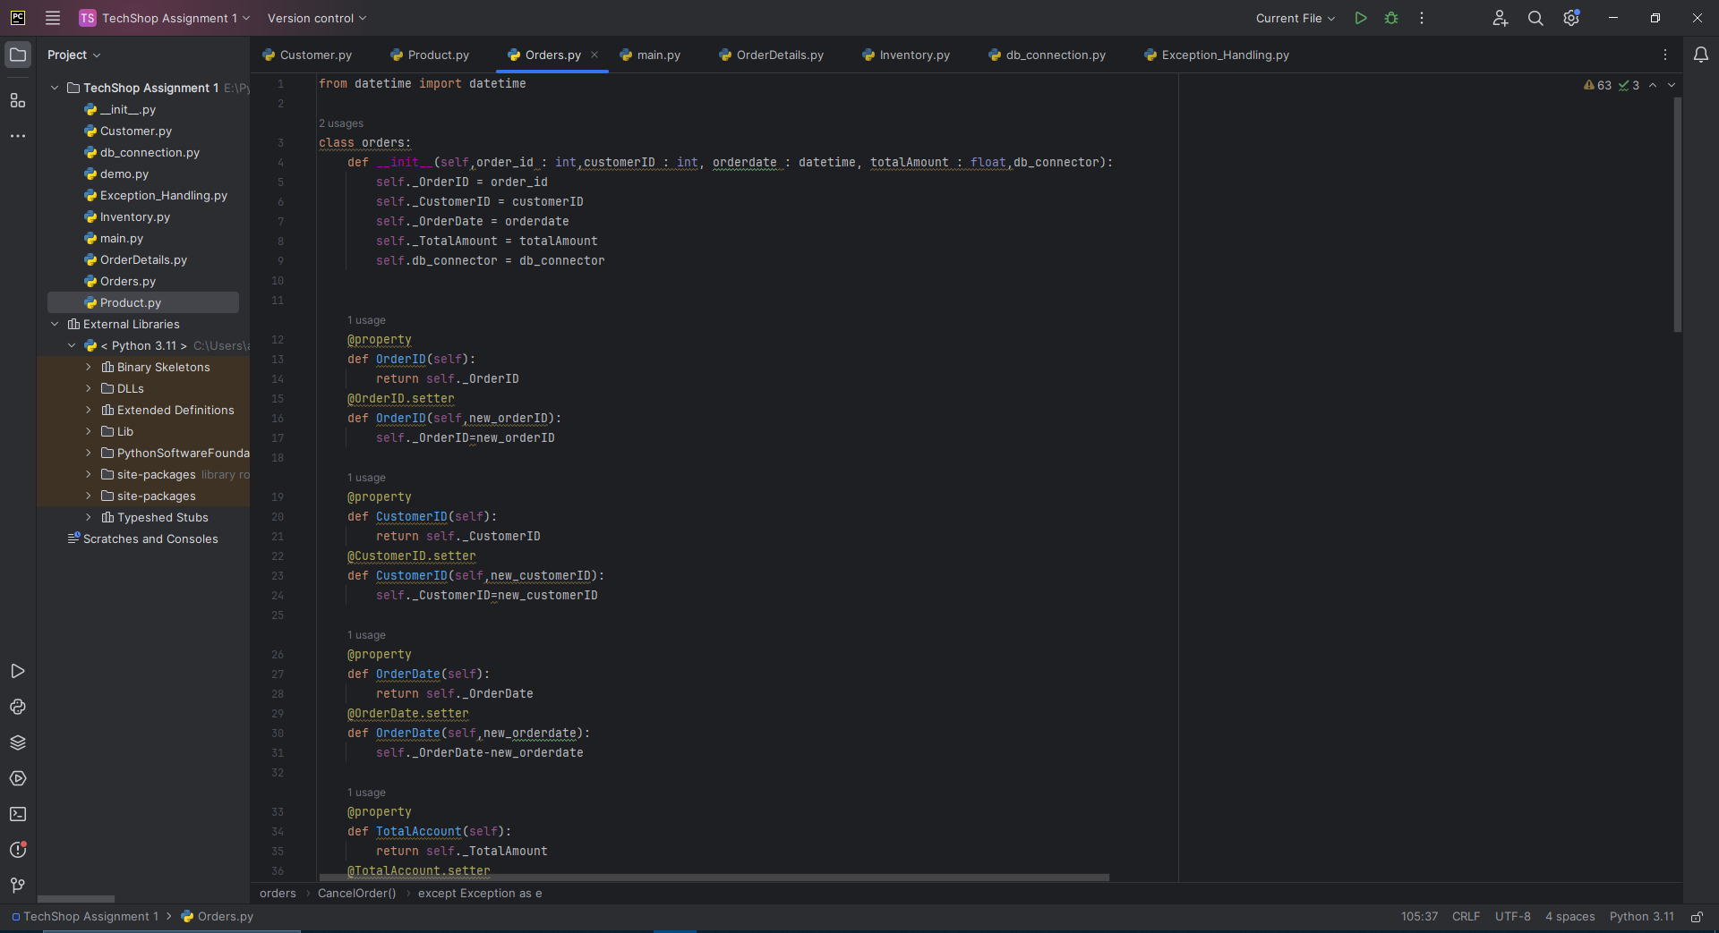

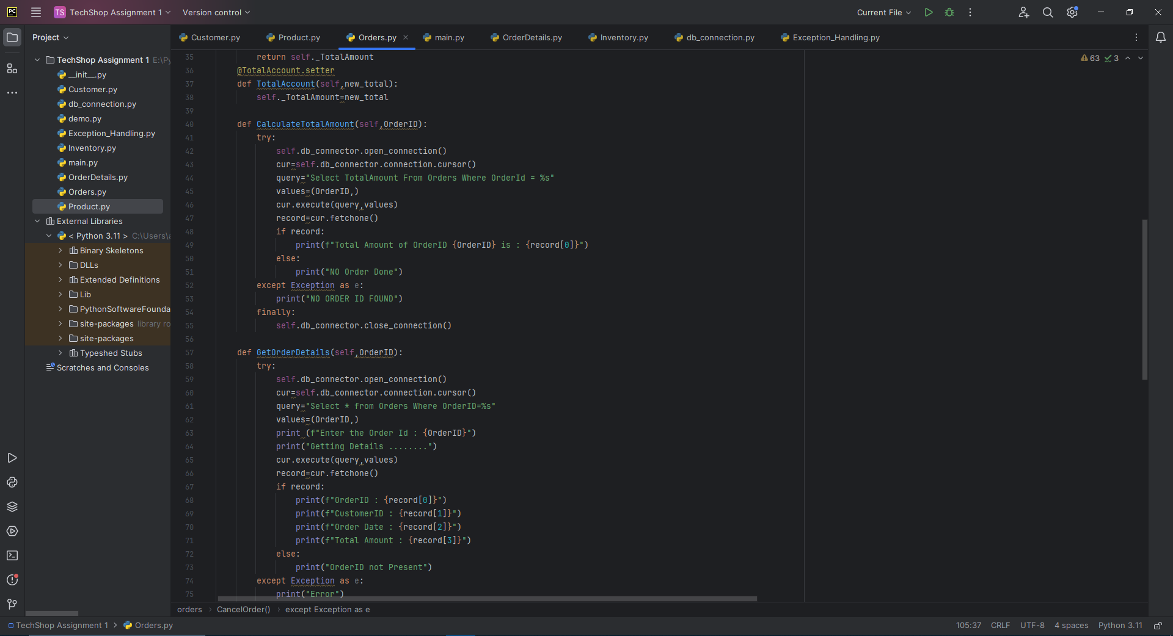

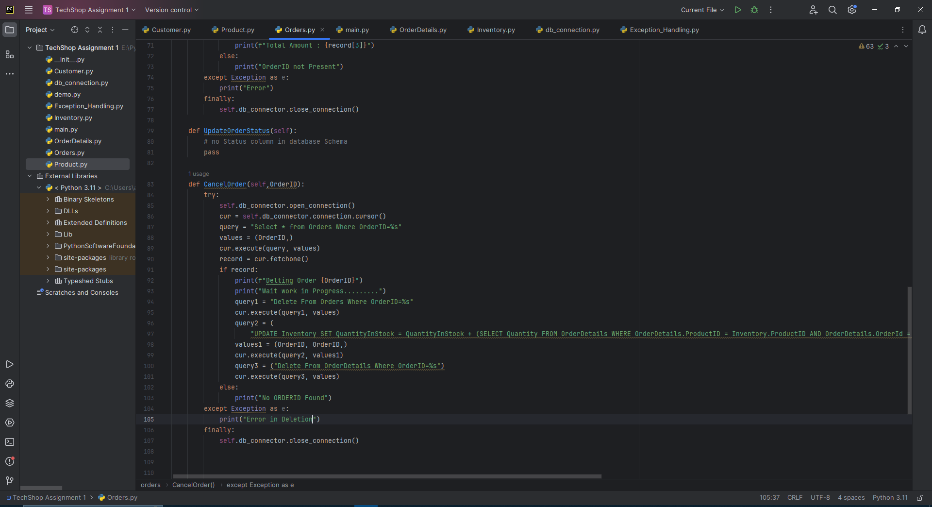

Calculating The Total Amount of a Particular Order:

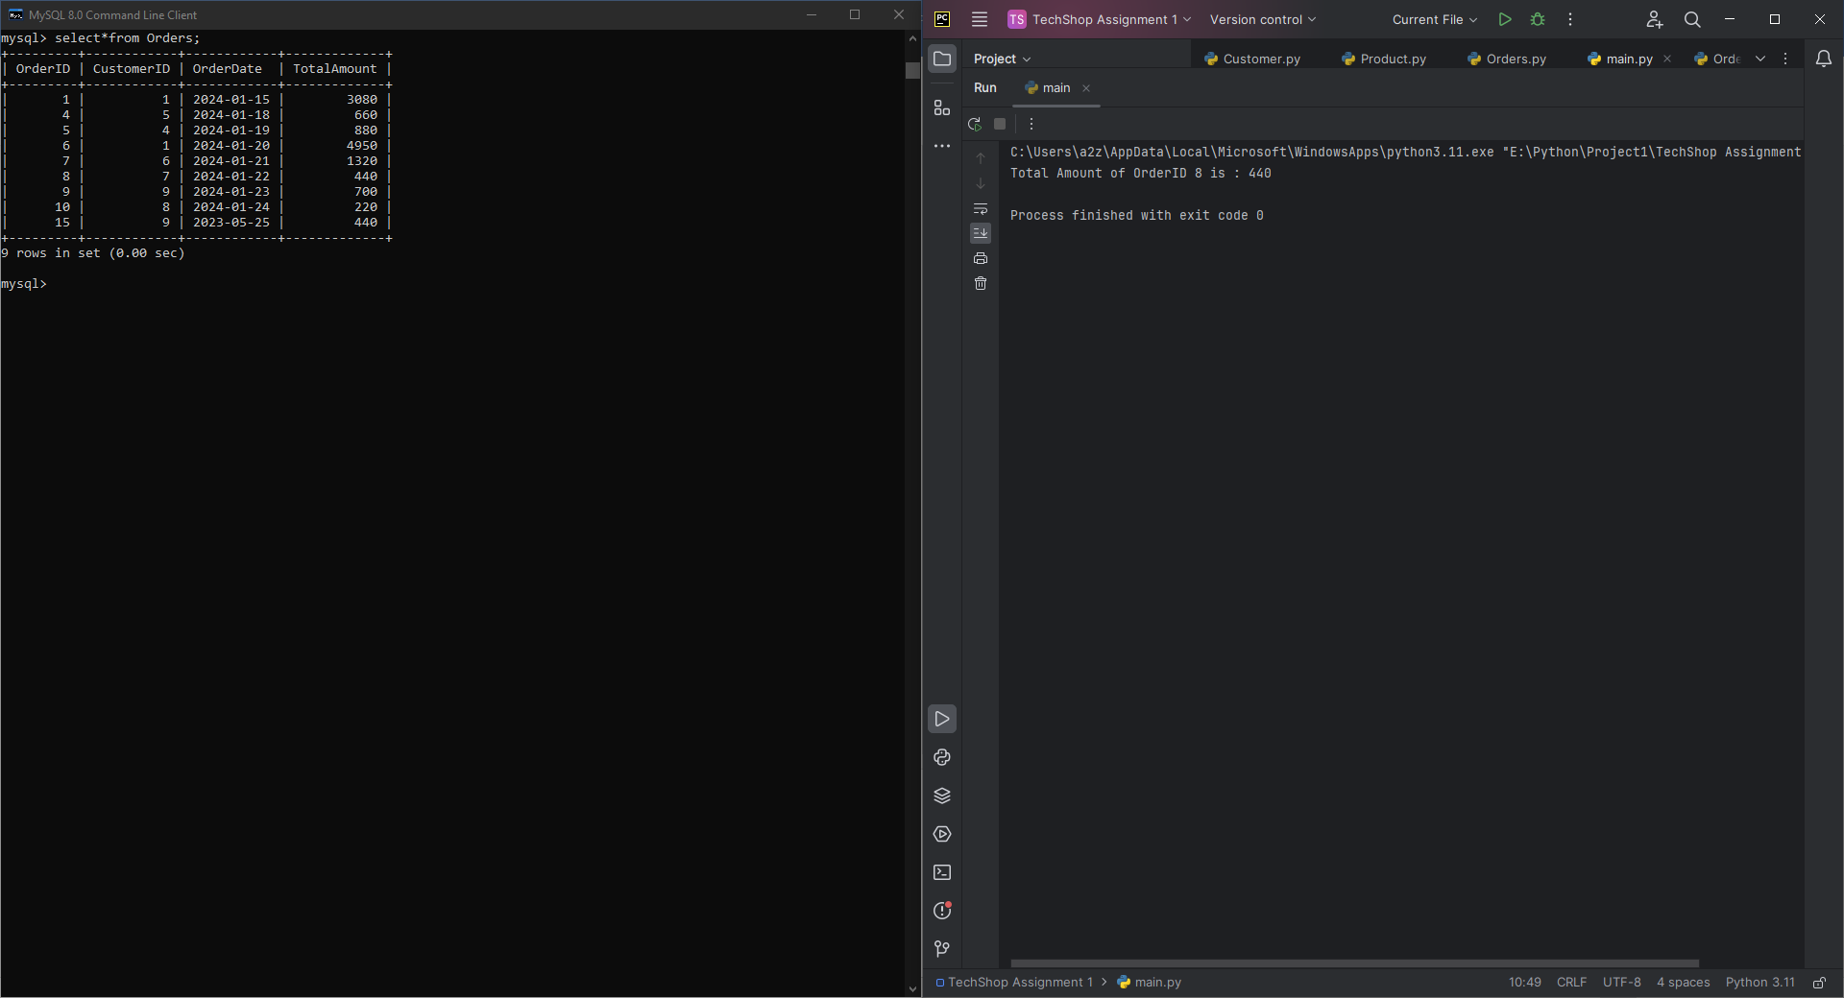

Getting info about a Particular Order

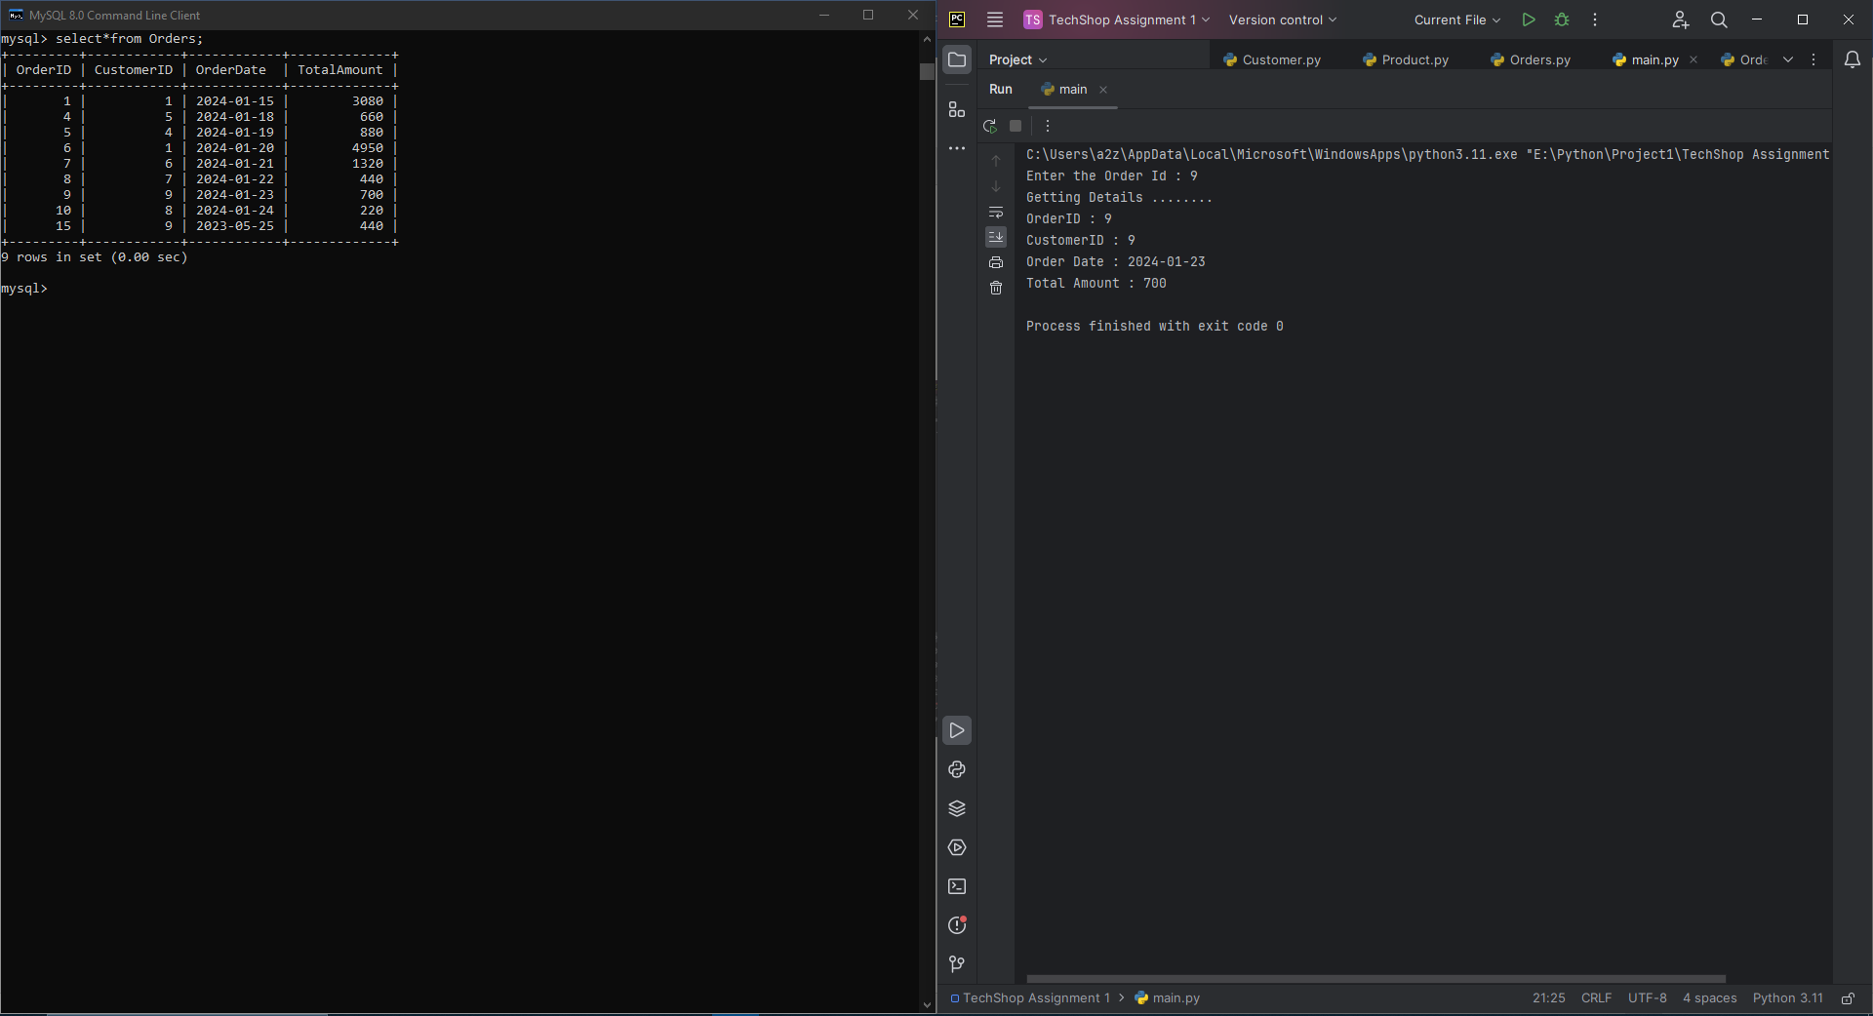

Cancelling Order

Cannot Delete Order Because we have Order Detail corresponding to that Order ID

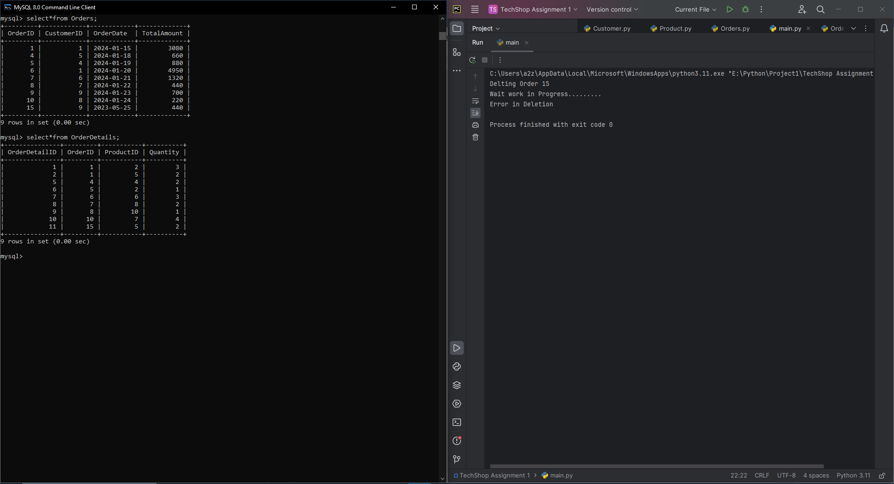

OrderDetails Class:

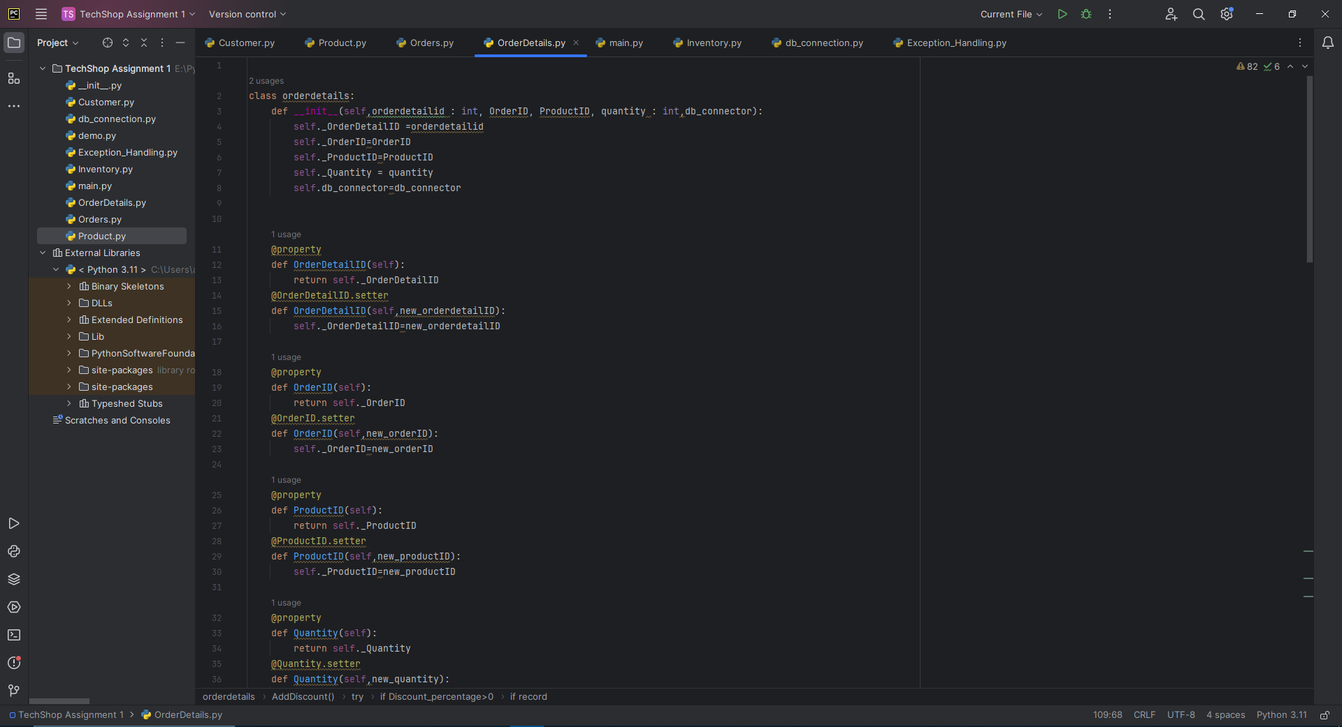

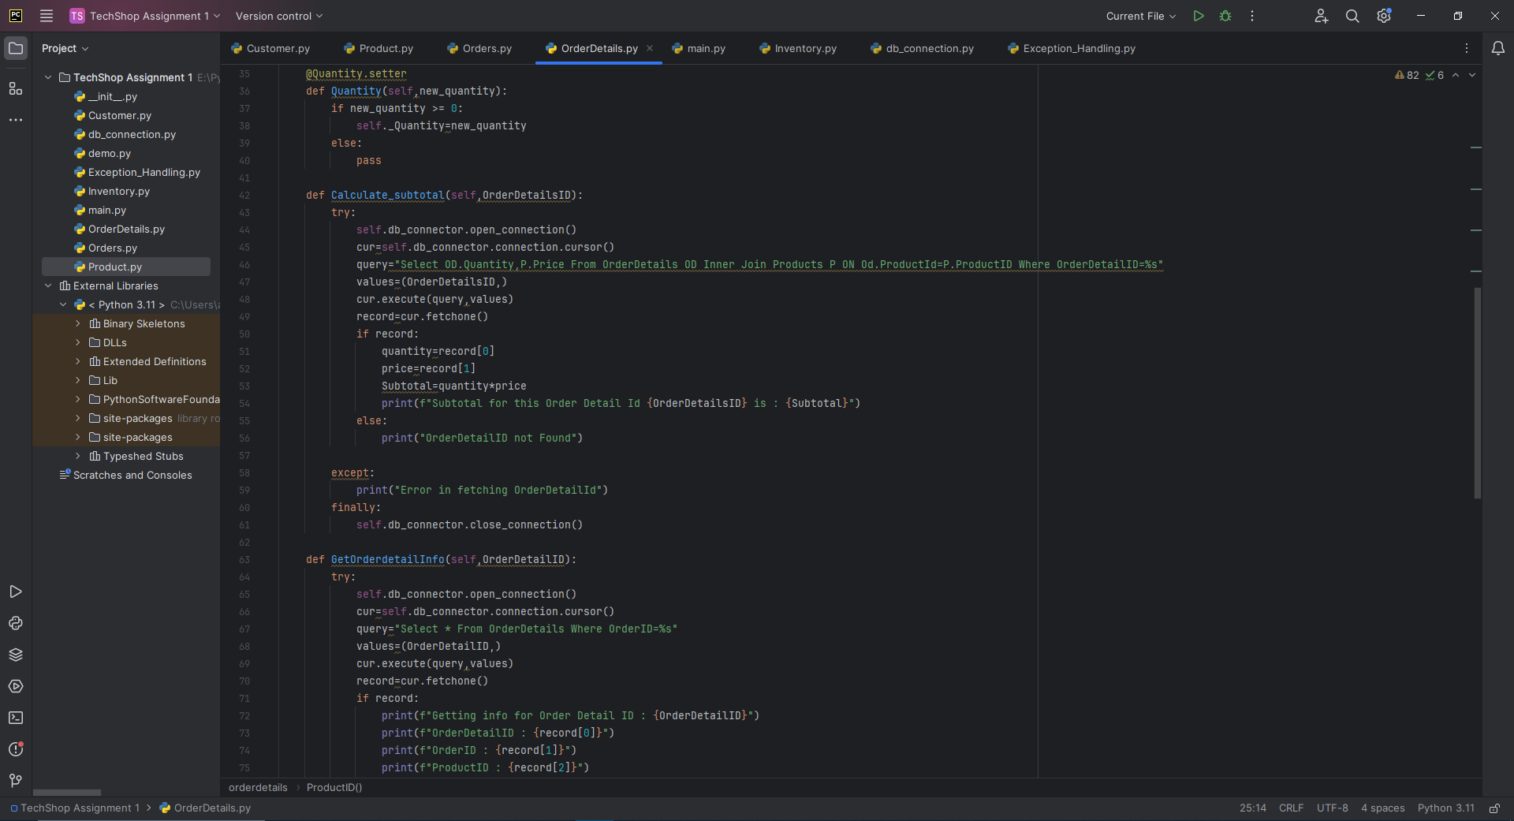

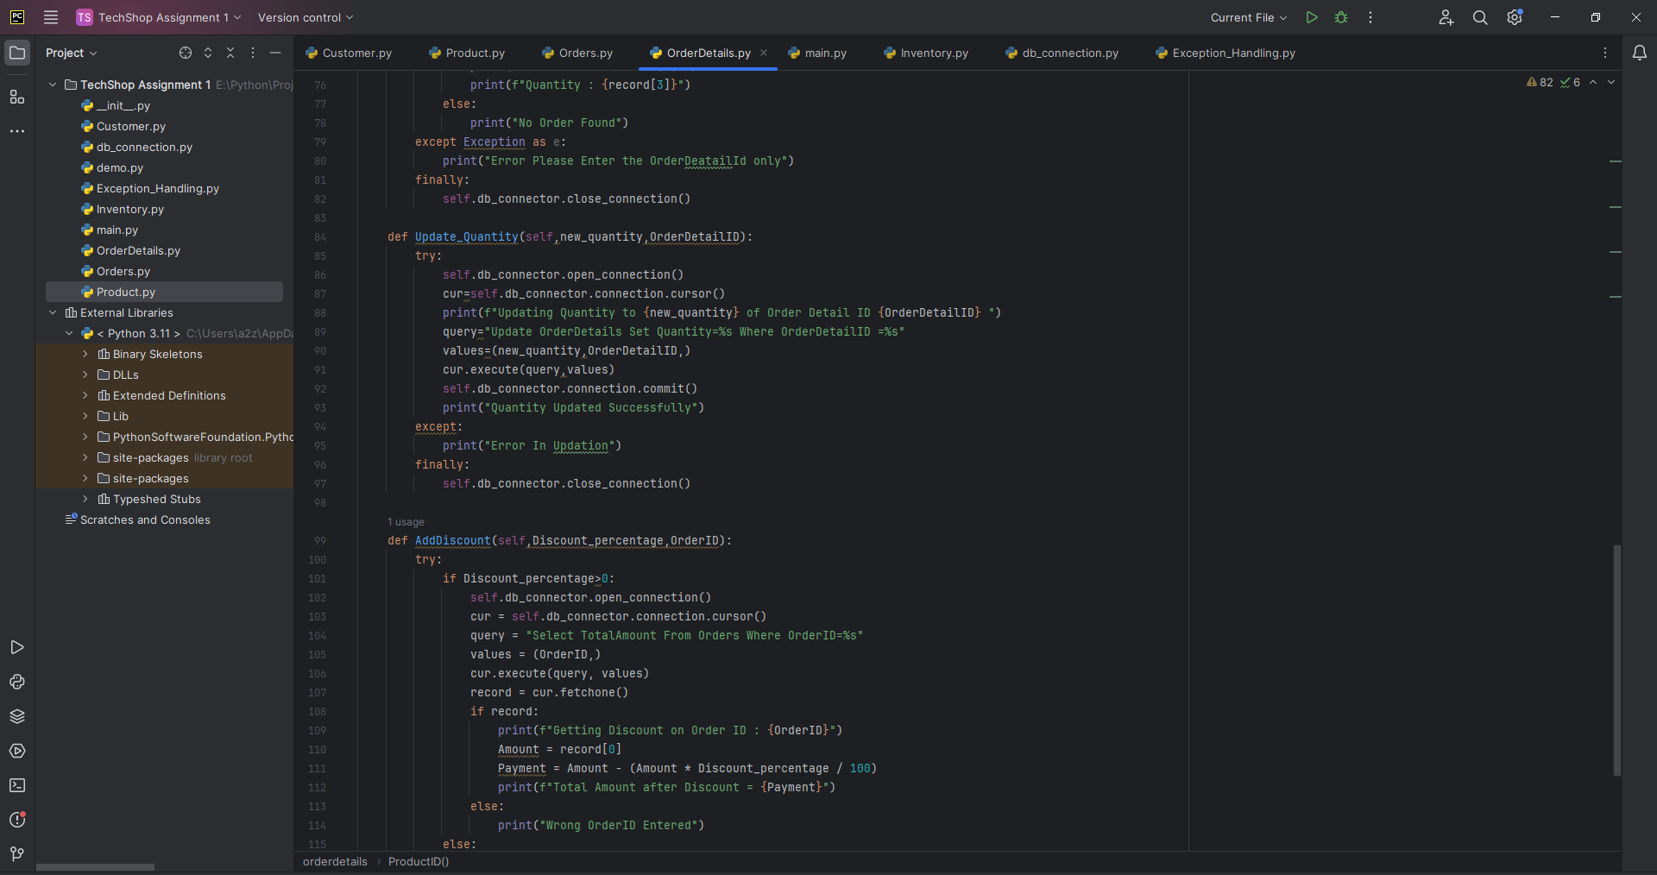

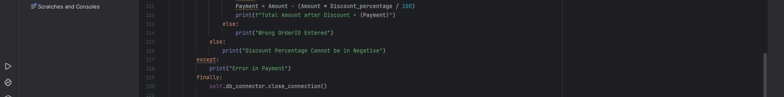

Calculating Subtotal of a Particular Order Detail

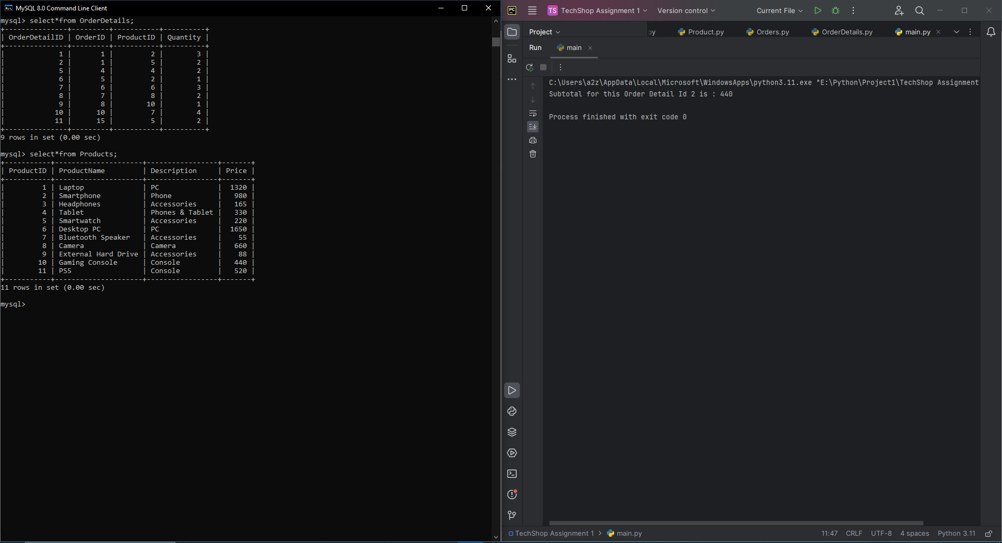

Getting all the info for a particular Order Detail

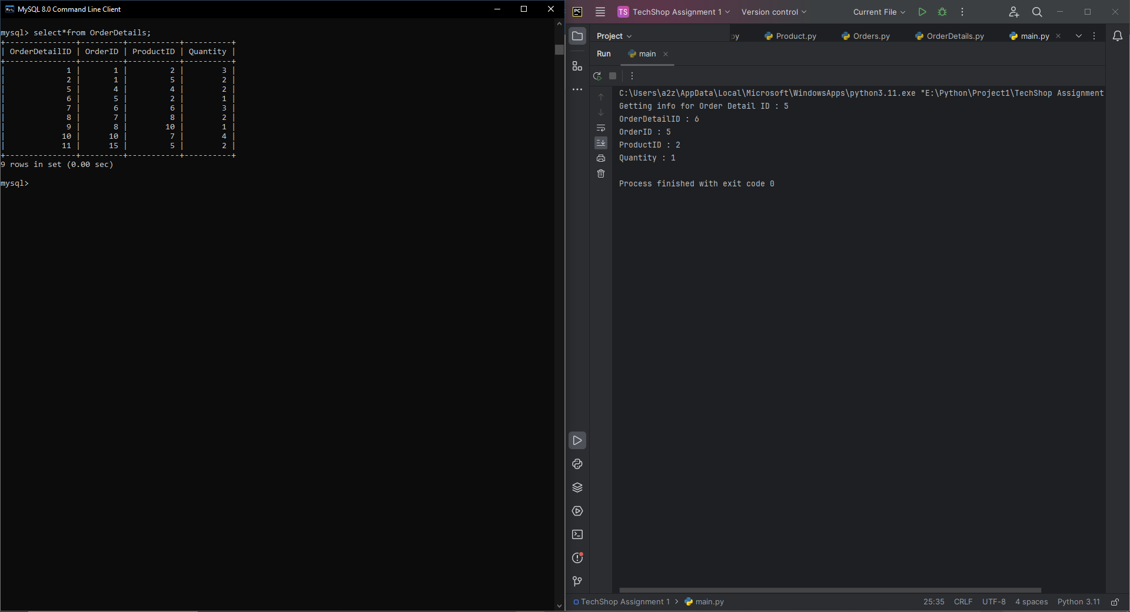

Updating the Quantity in the Order Detail

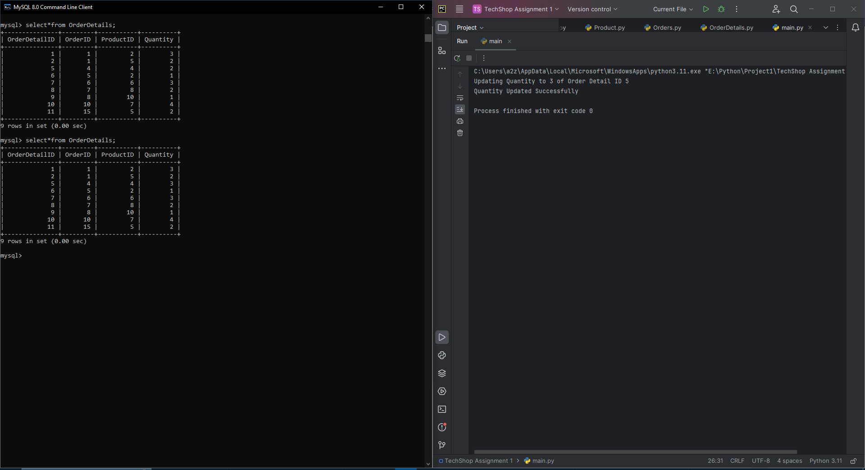

Adding Discount in Total Bill

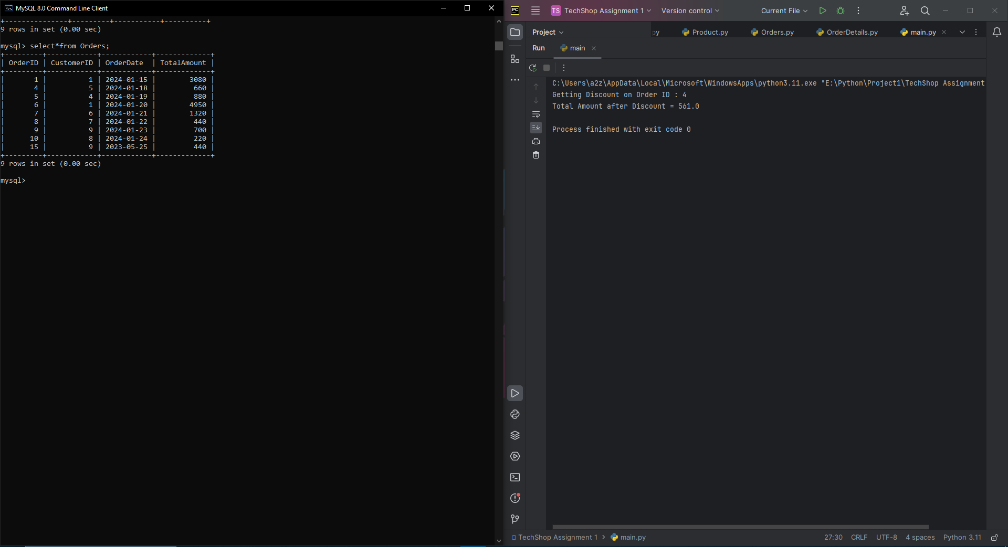

Inventory Class:

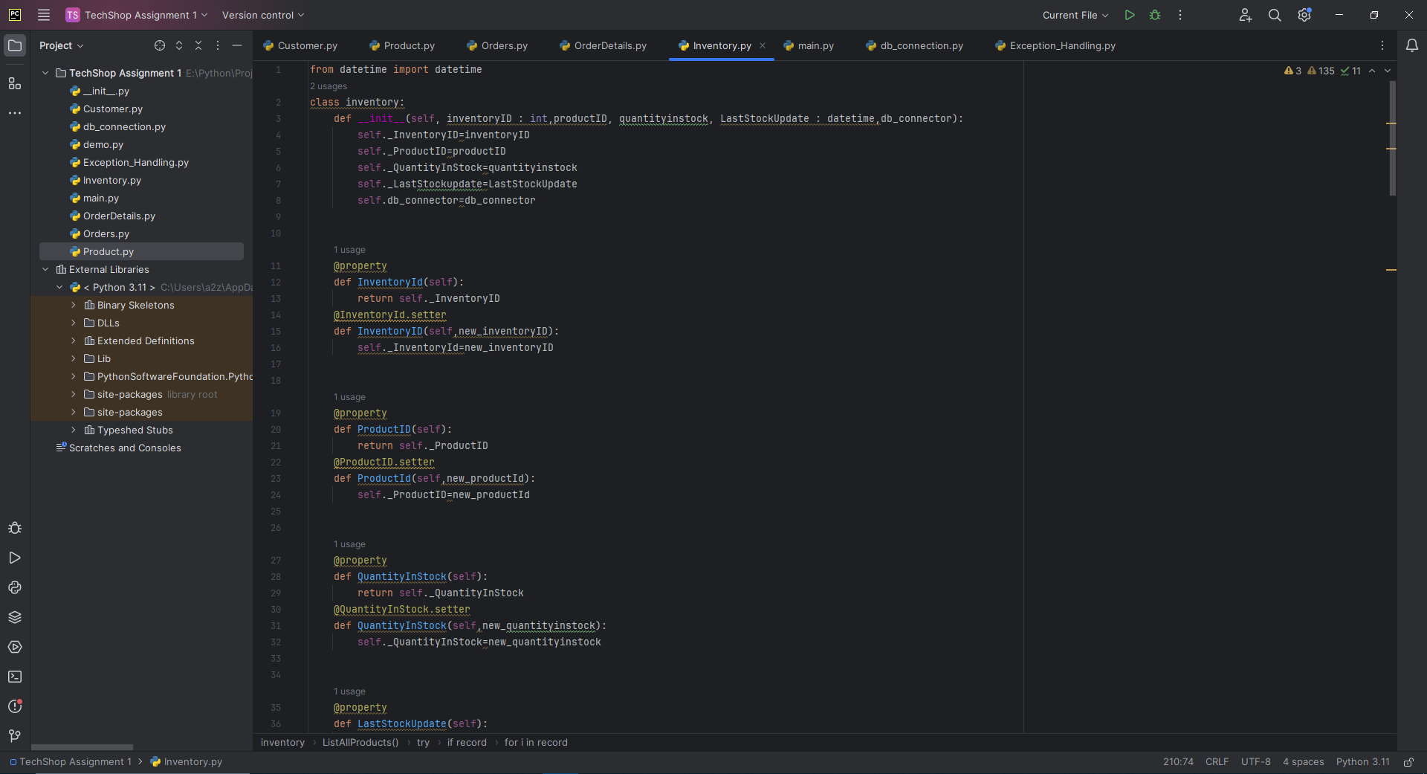

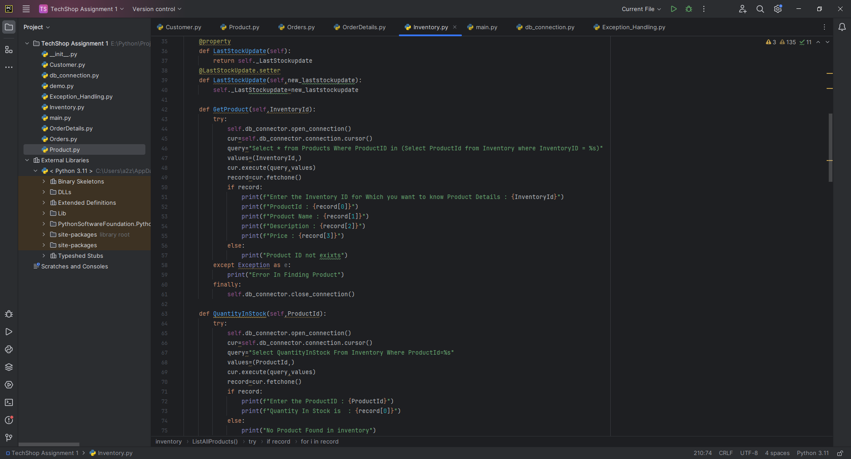

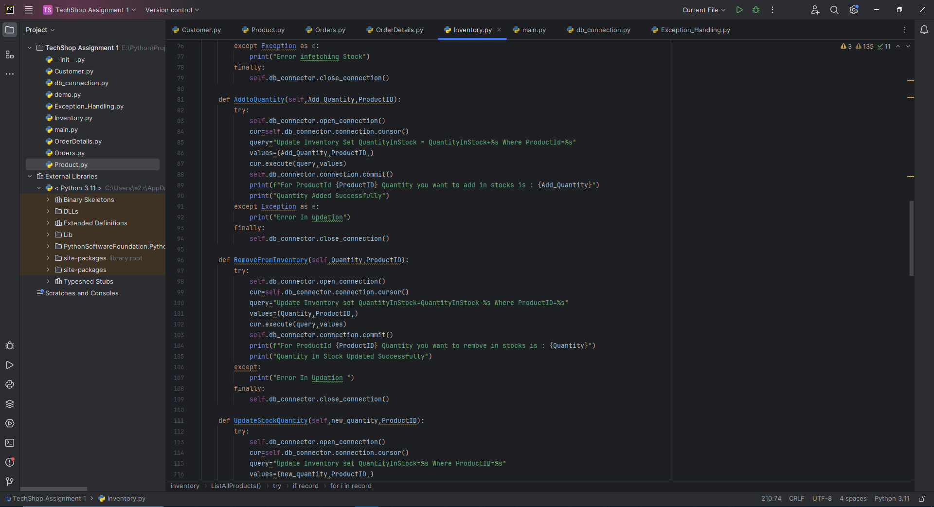

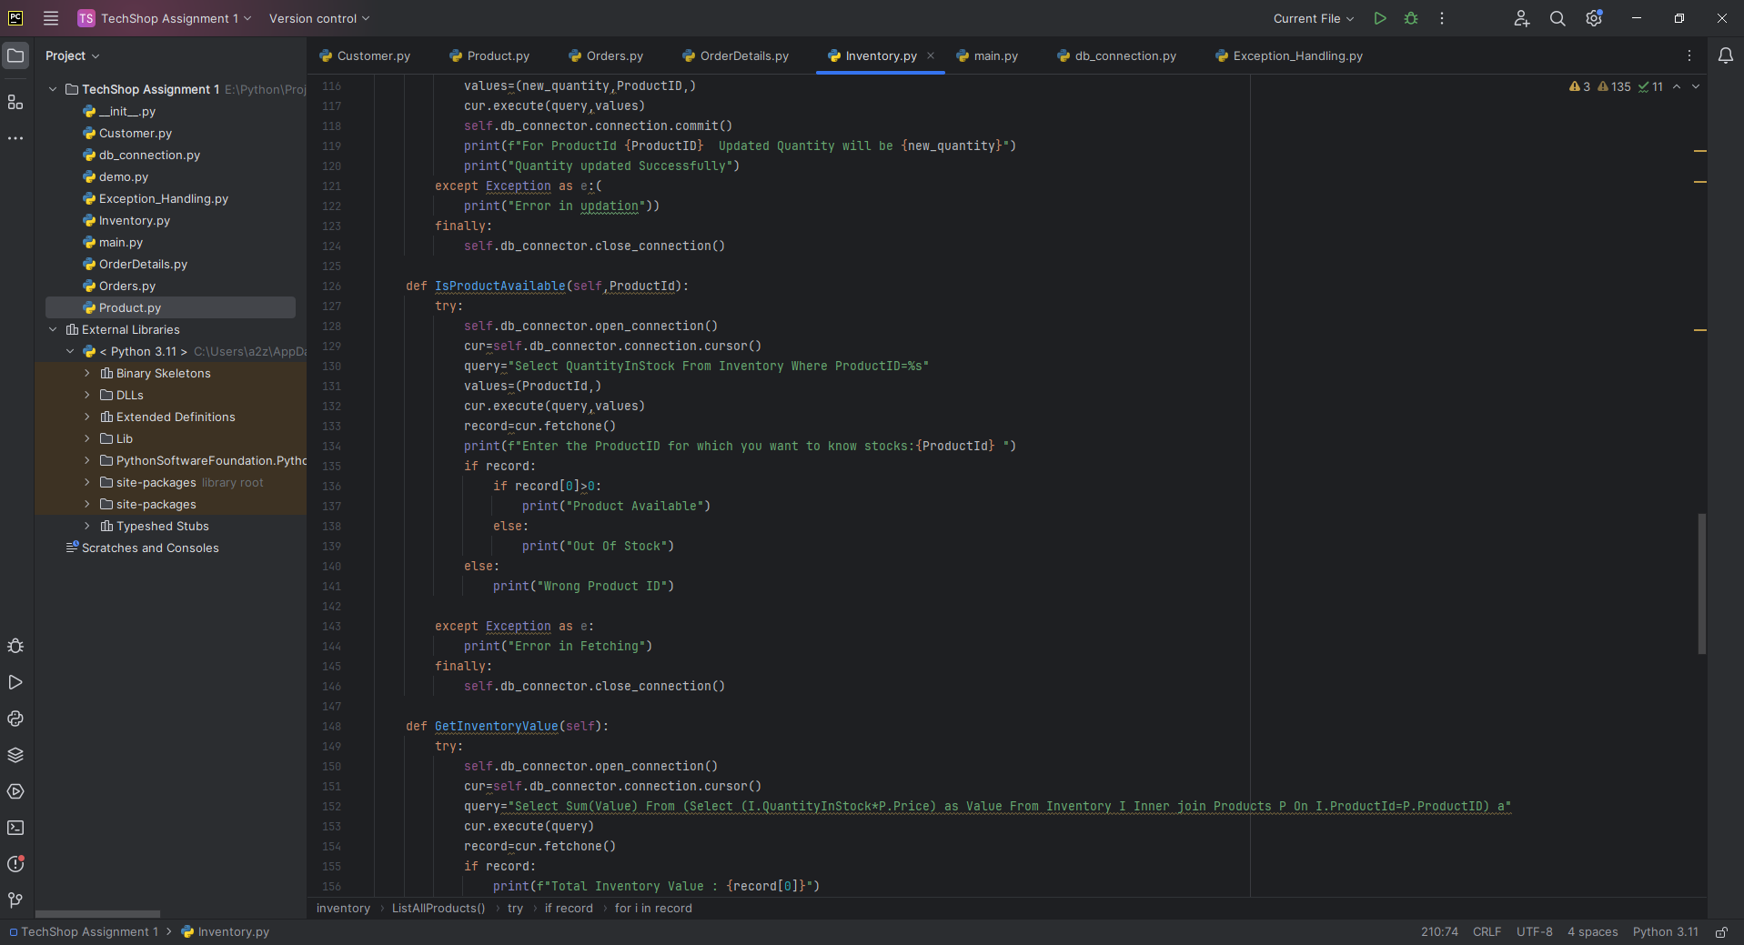

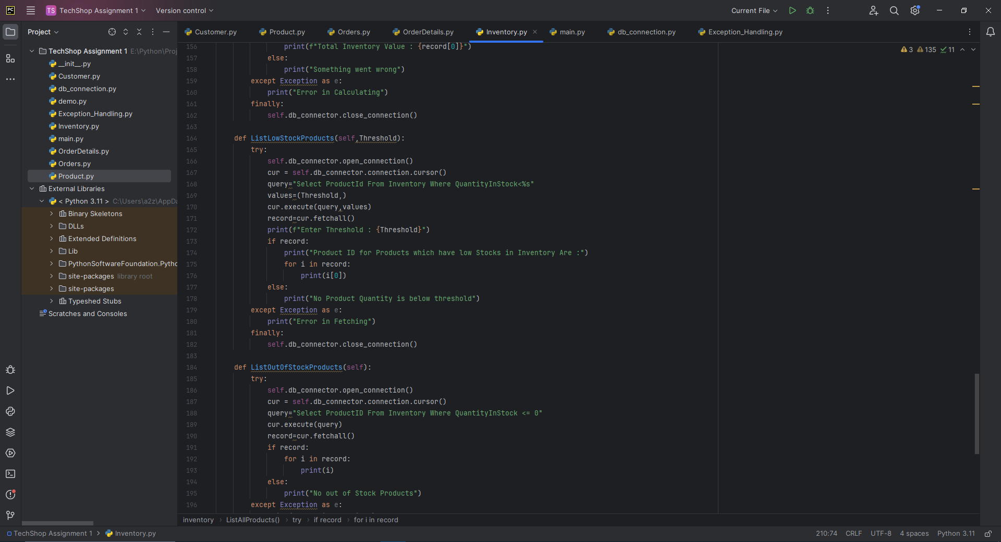

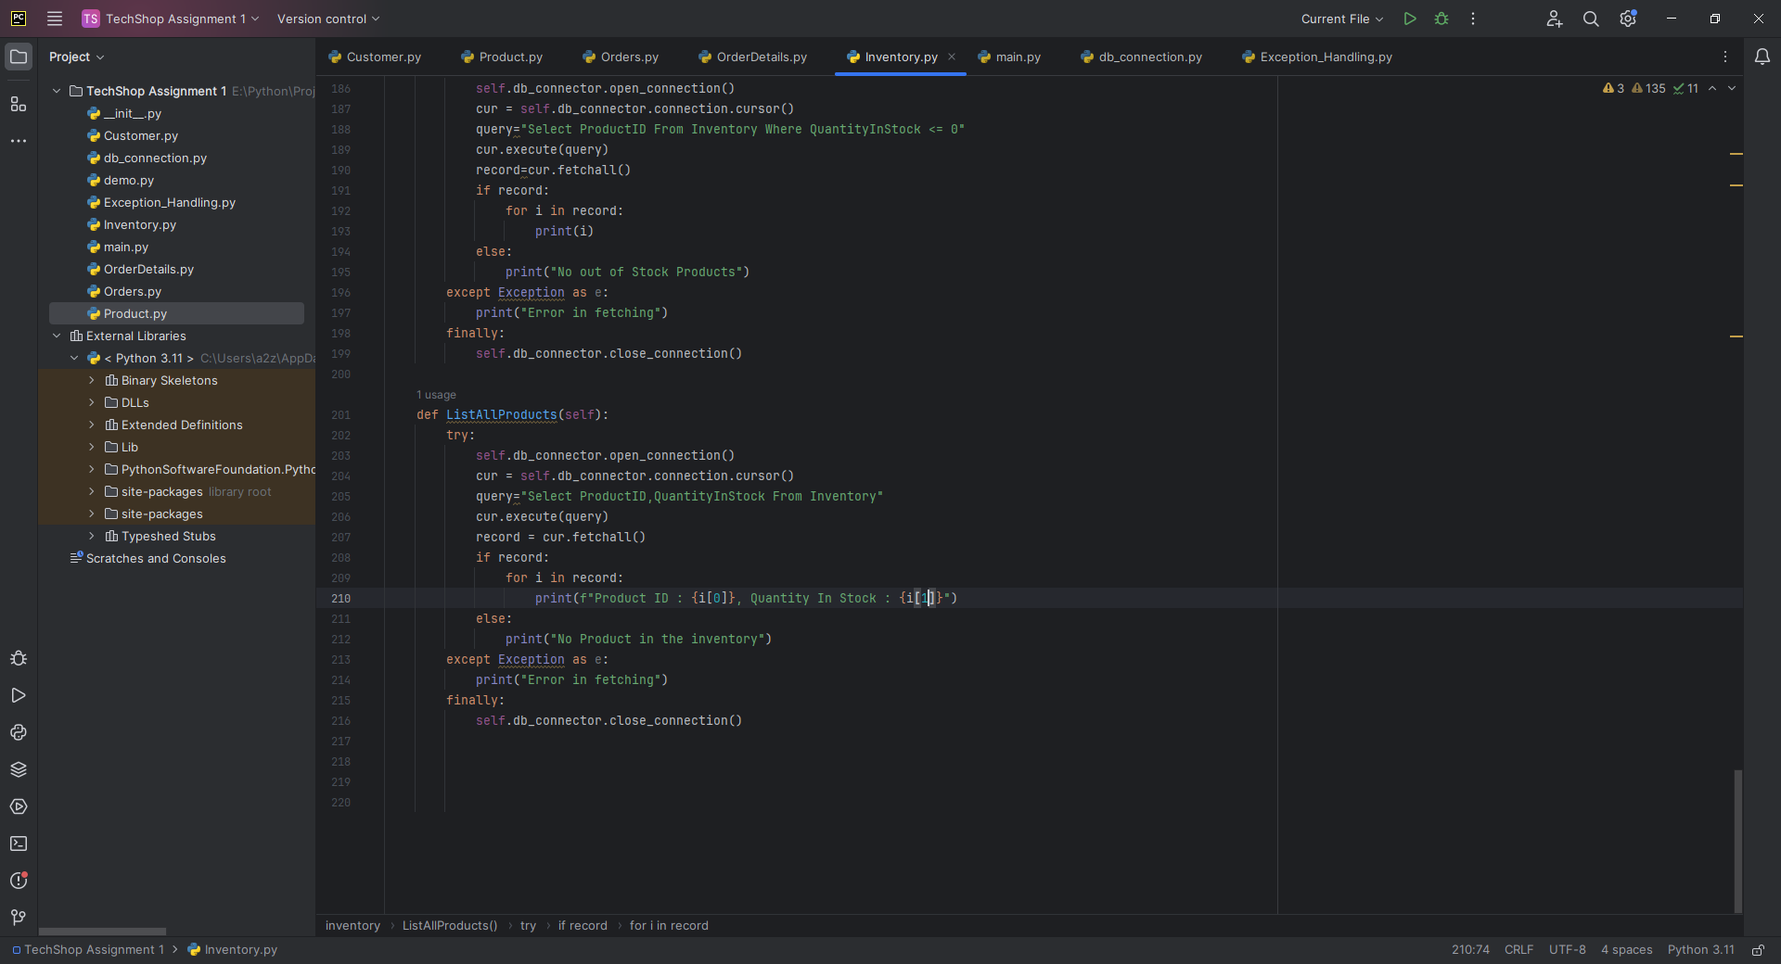

GetProduct(): A method to retrieve the product associated with this inventory item.

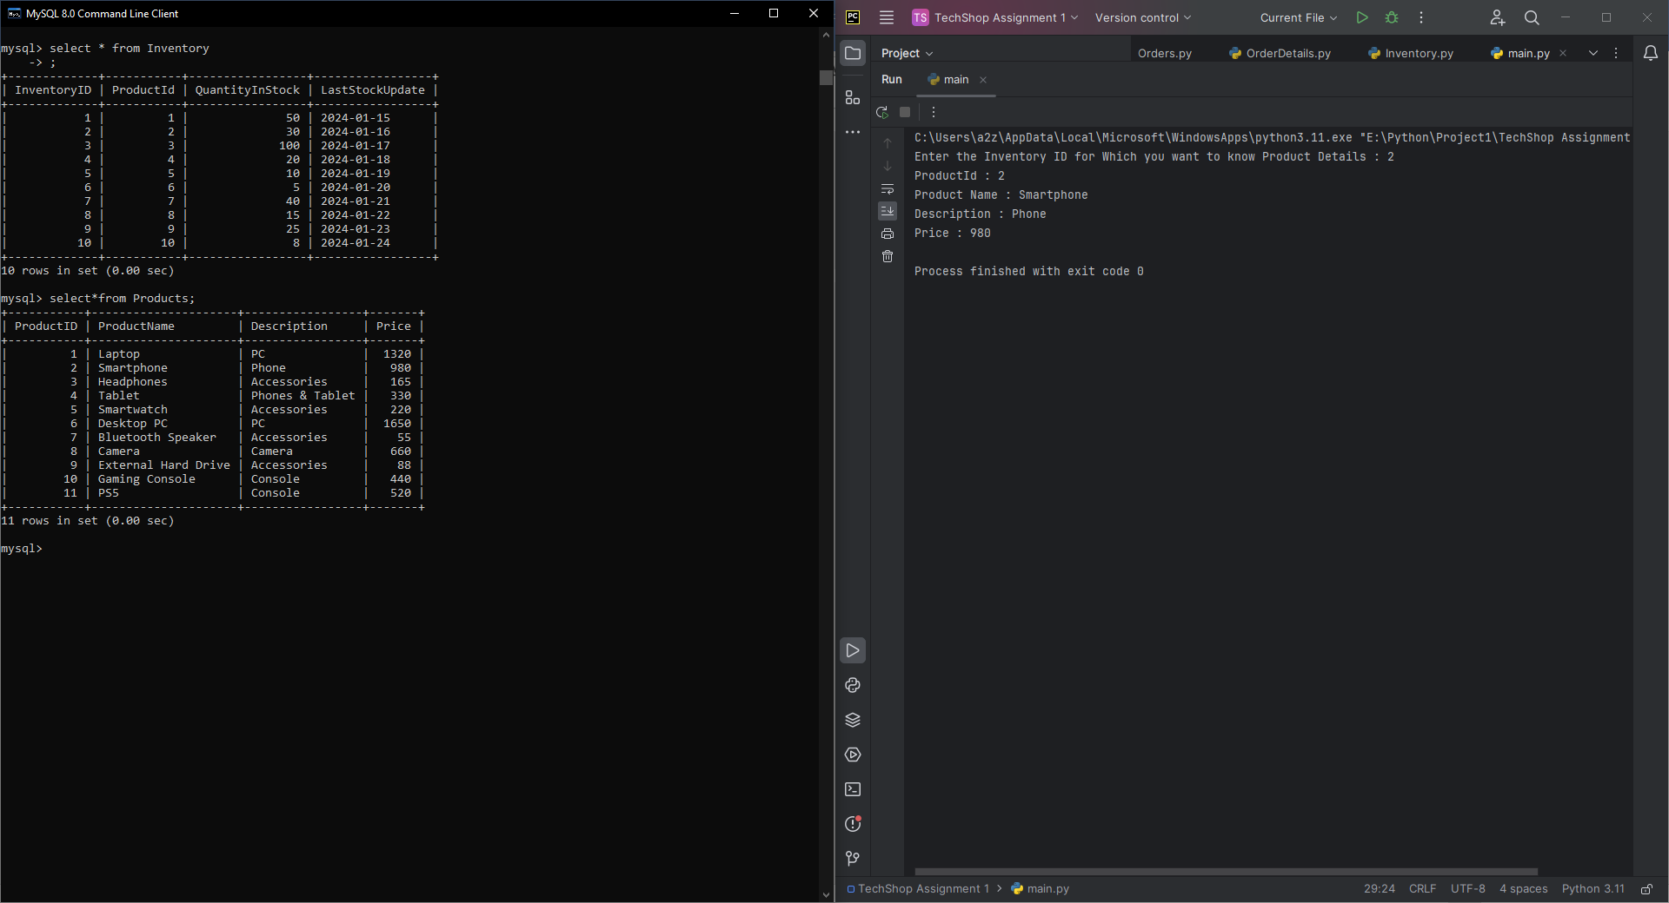

GetQuantityInStock(): A method to get the current quantity of the product in stock.

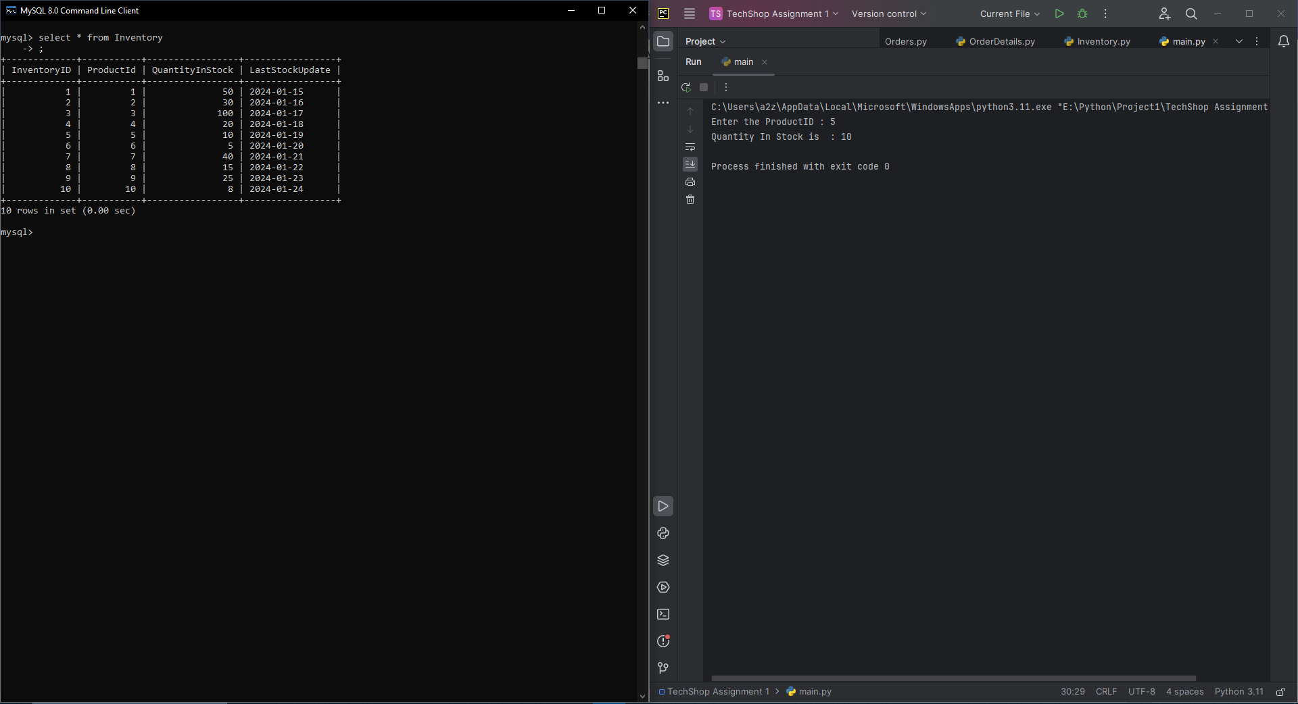

AddToInventory(int quantity): A method to add a specified quantity of the product to the inventory.

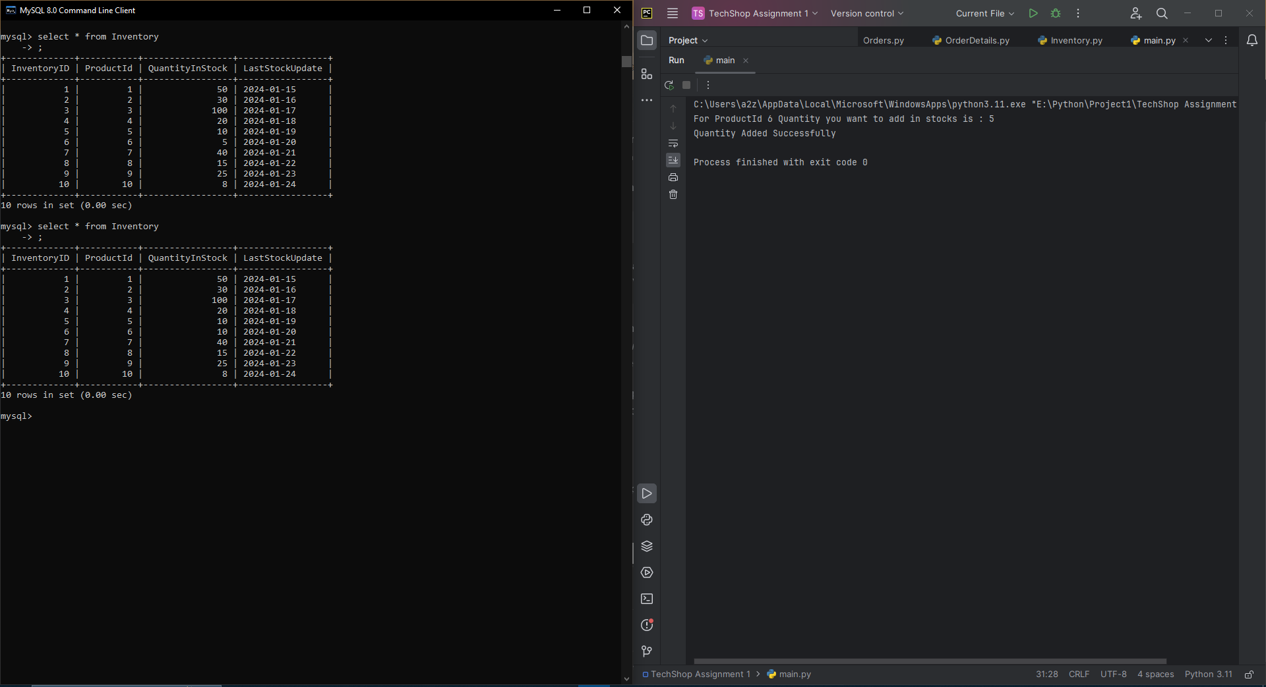

RemoveFromInventory(int quantity): A method to remove a specified quantity of the product from the inventory.

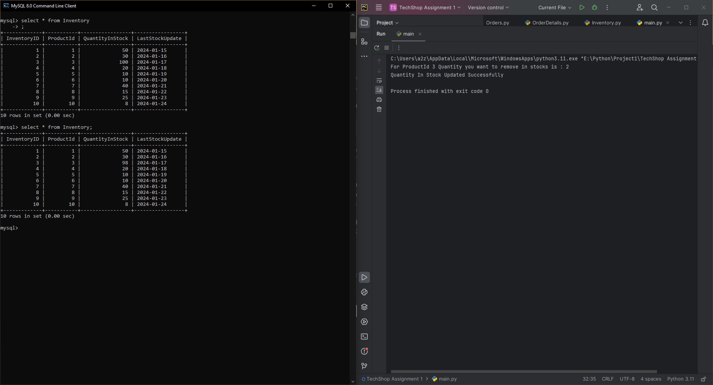

UpdateStockQuantity(int newQuantity): A method to update the stock quantity to a new value.

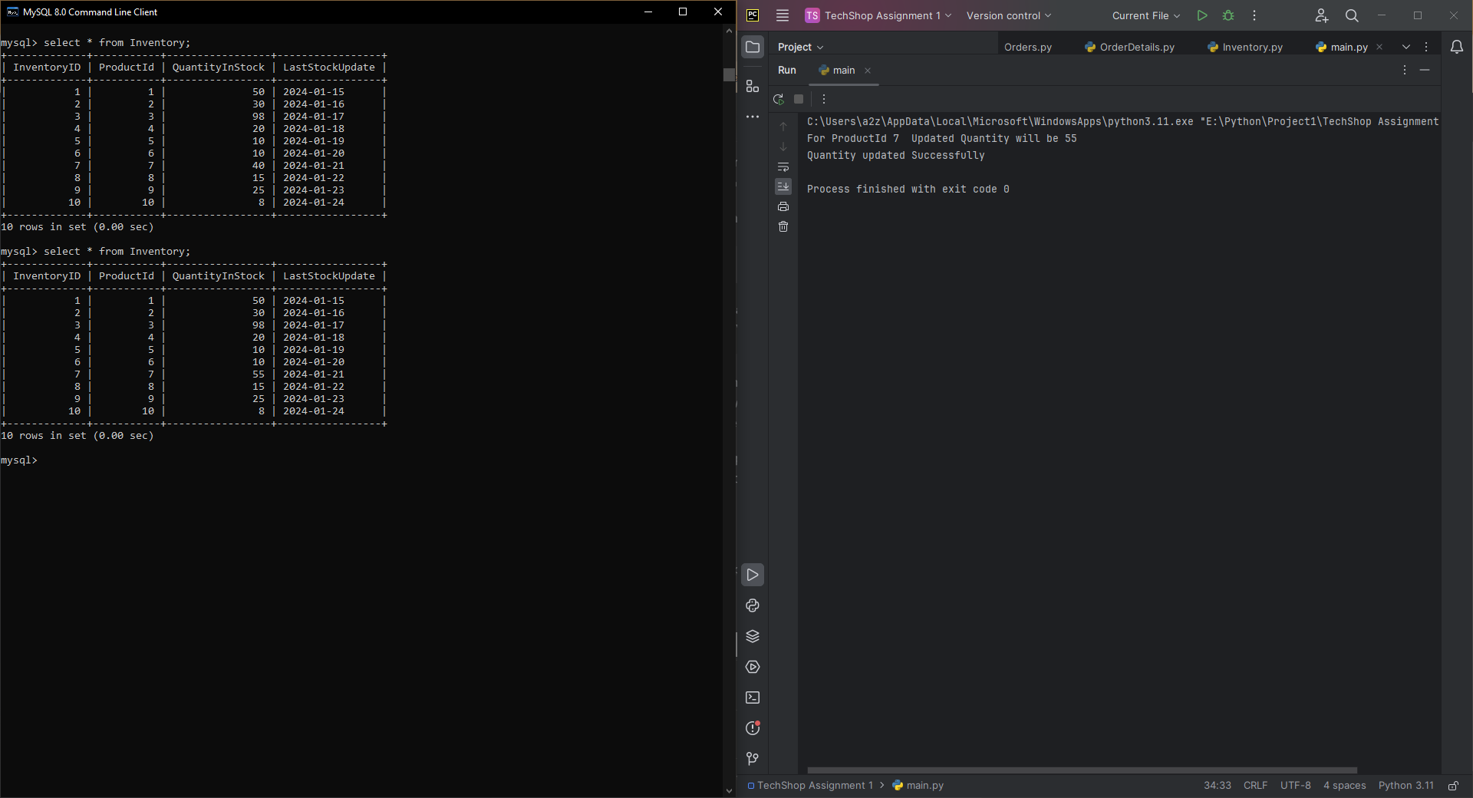

IsProductAvailable(int quantityToCheck): A method to check if a specified quantity of the product is available in the inventory.

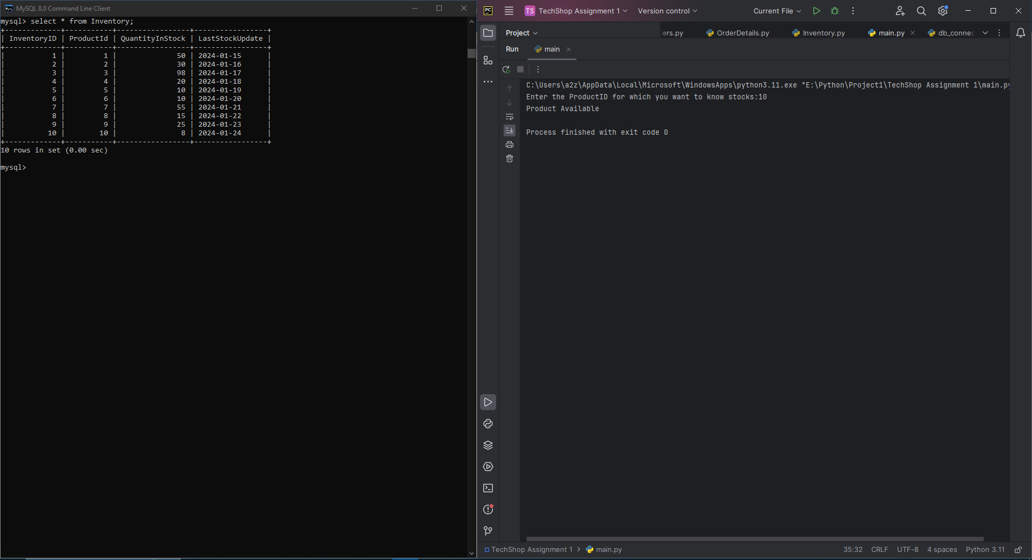

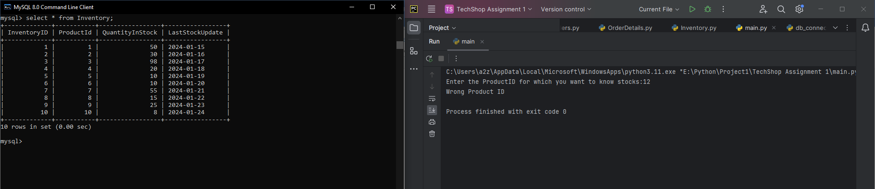

GetInventoryValue(): A method to calculate the total value of the products in the inventory based on their prices and quantities.

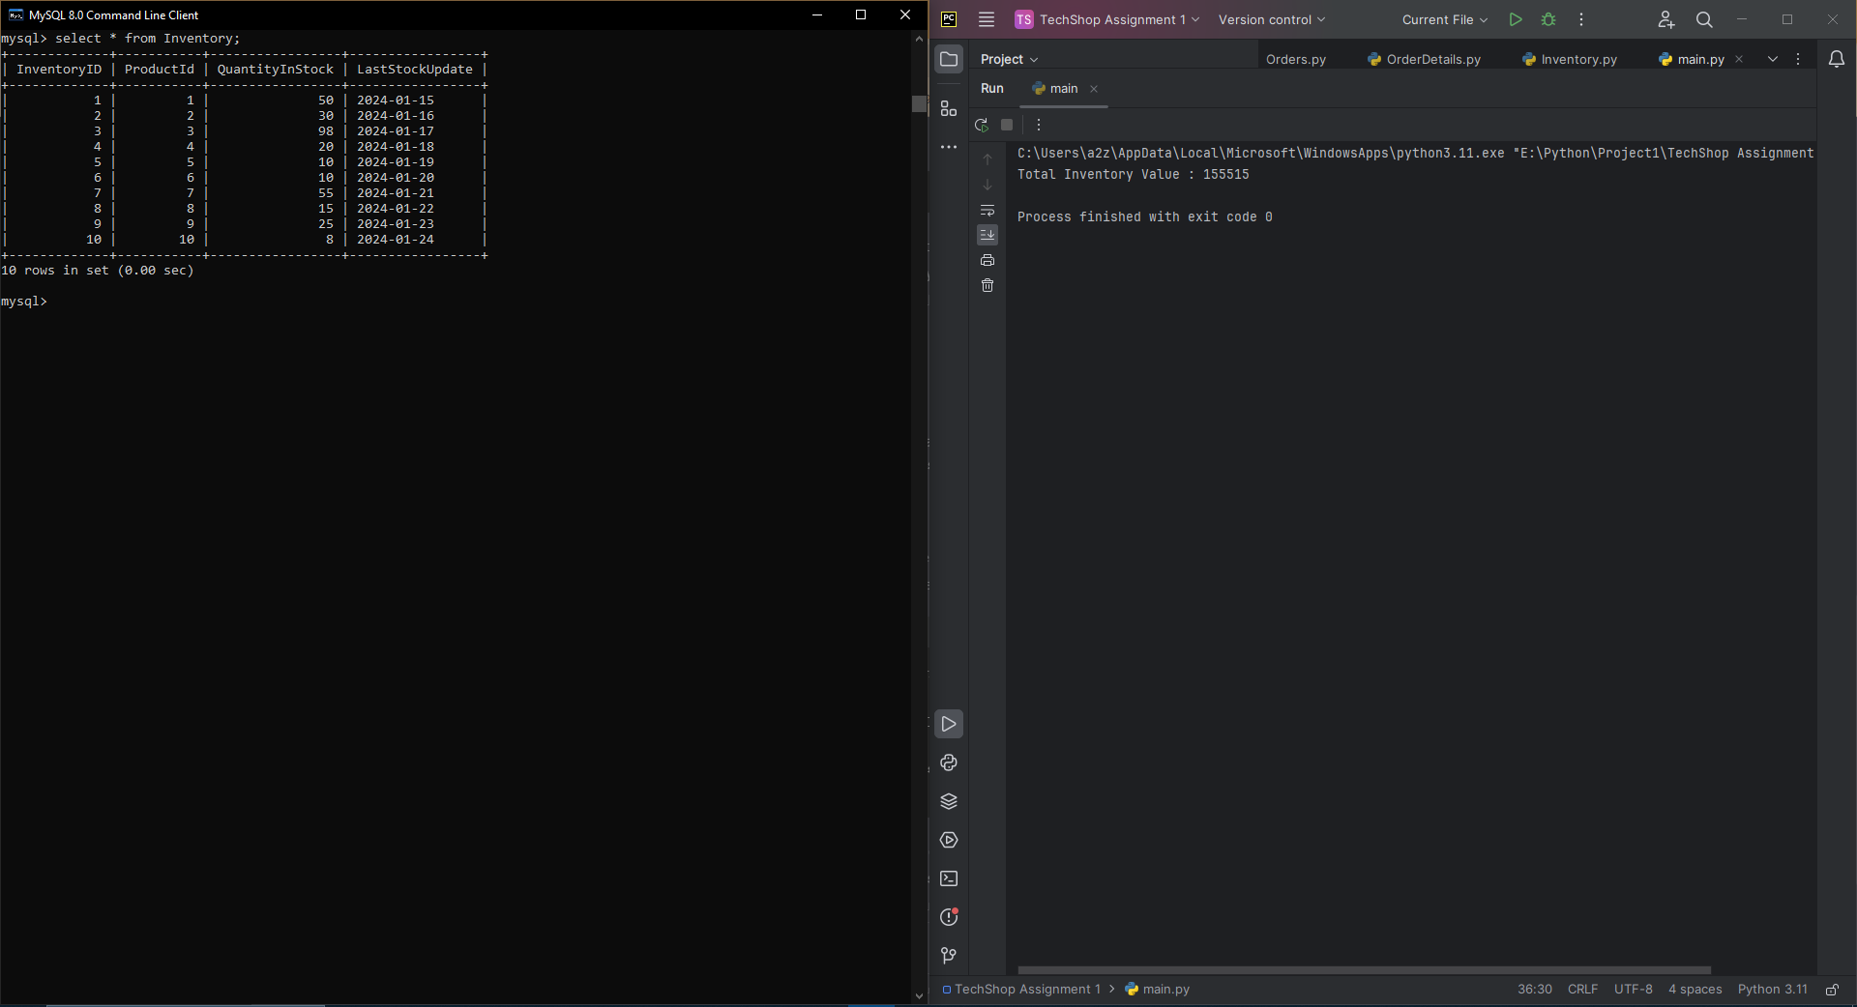

ListLowStockProducts(int threshold): A method to list products with quantities below a specified threshold, indicating low stock.

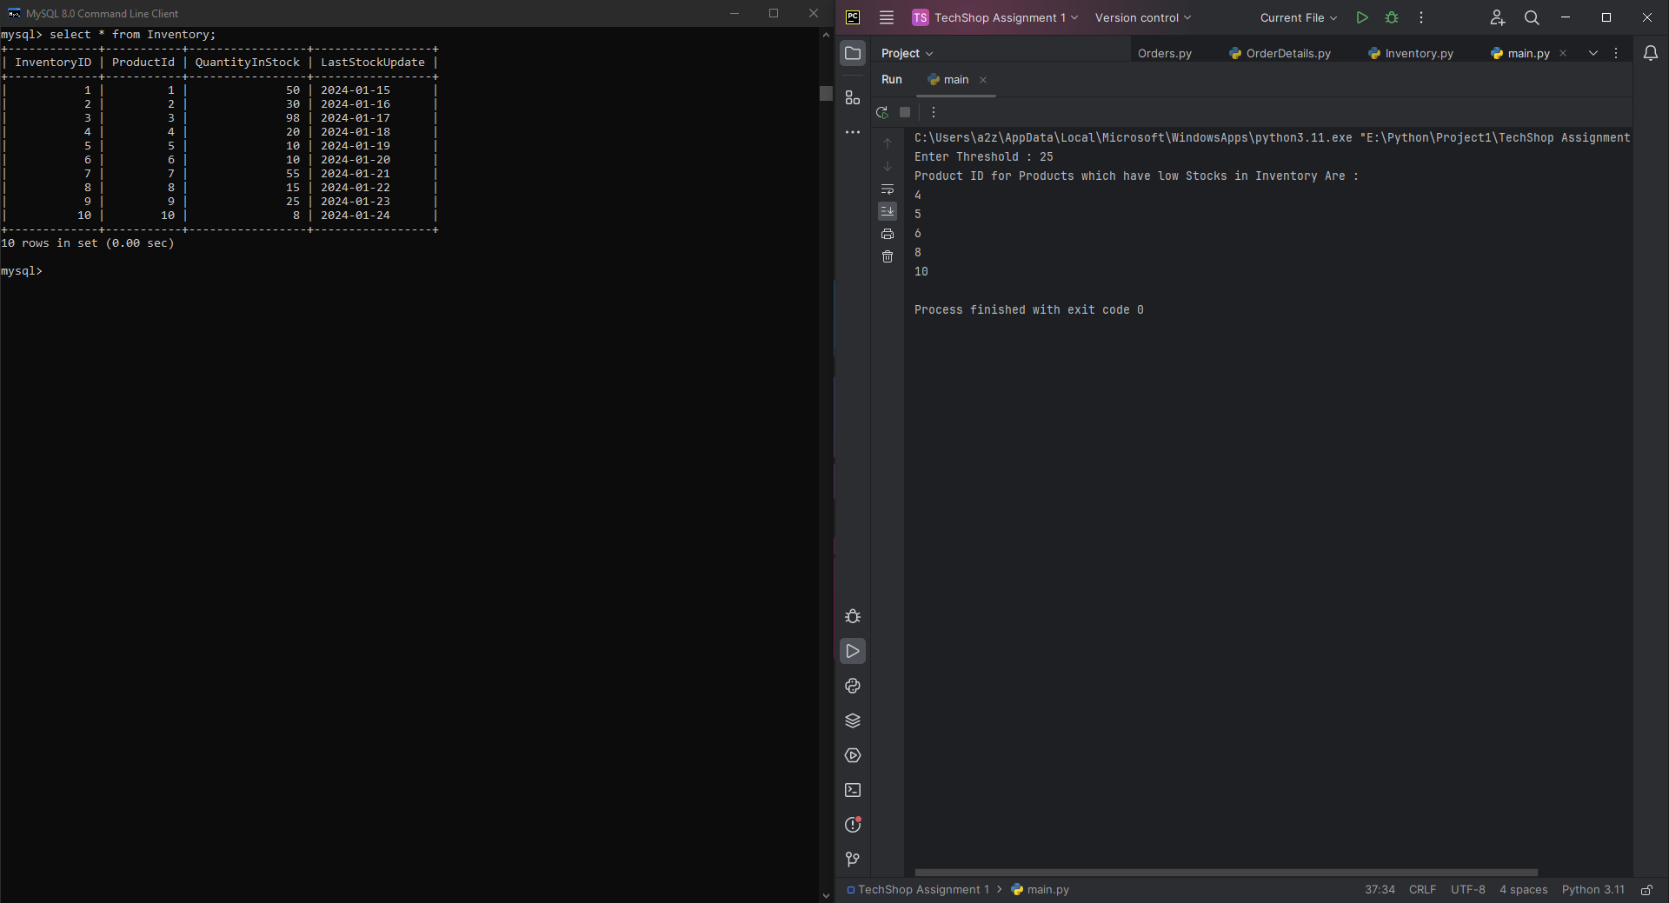

ListOutOfStockProducts(): A method to list products that are out of stock.

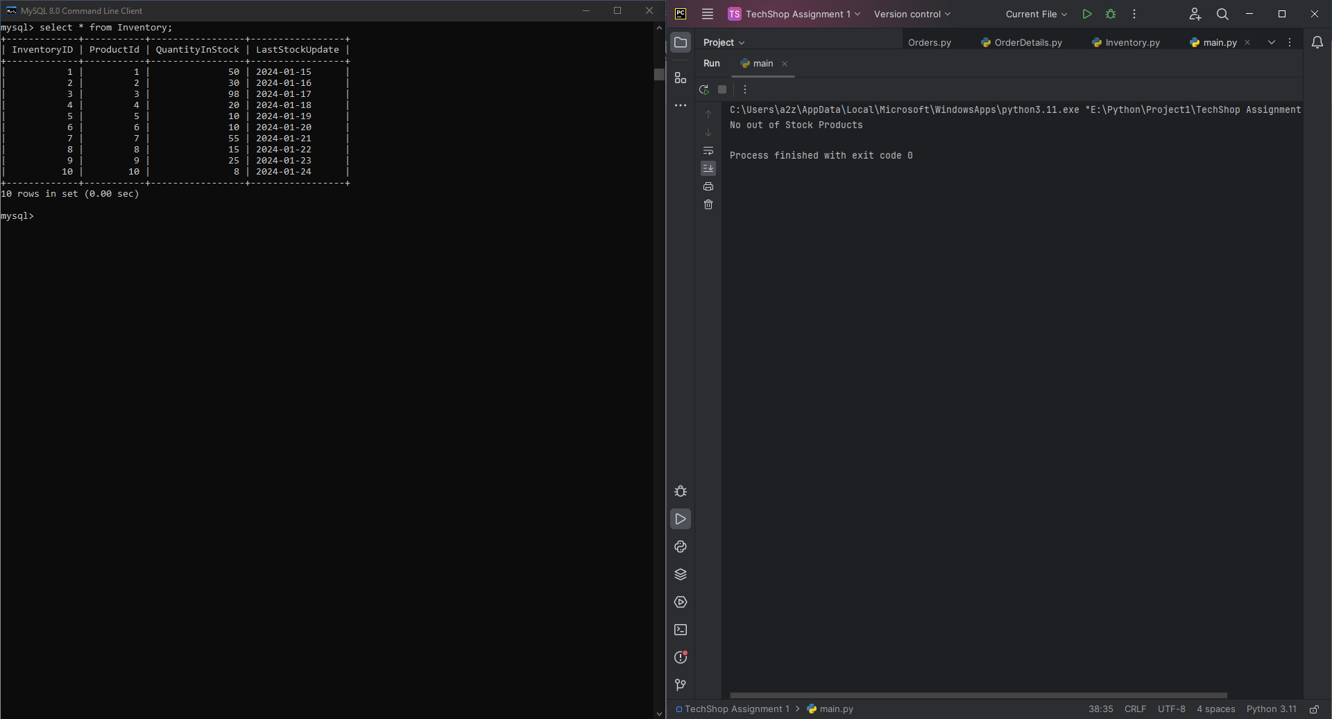

ListAllProducts(): A method to list all products in the inventory, along with their quantities.

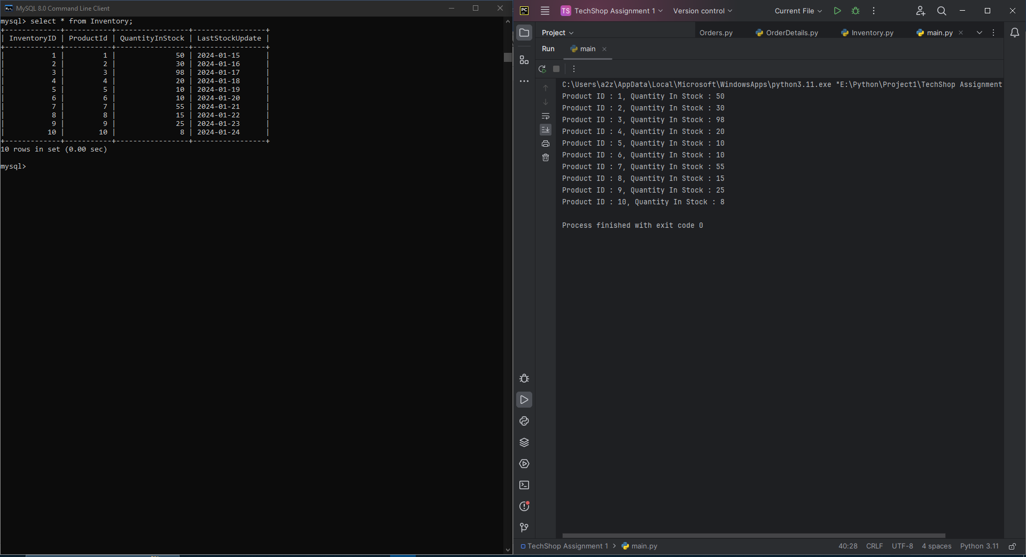

Database Connectivity

